Collaboration, Connection, Community
Strategic Plan 2019-2021
BALANCE for Blind Adults
WHO WE ARE
BALANCE for Blind Adults is a support organization providing individualized, specialized services for independent living to persons who are blind or living with sight loss. We have provided this skills training and support in Toronto for over 30 years. Our goal is to enhance each client’s ability to achieve optimal independence and community engagement. Many of our clients live with other challenges, including physical and mental health conditions, social isolation, speaking English as a second language and limited financial means. Thus, BALANCE views clients holistically, and customizes each service plan to meet clients’ often diverse and complex needs.
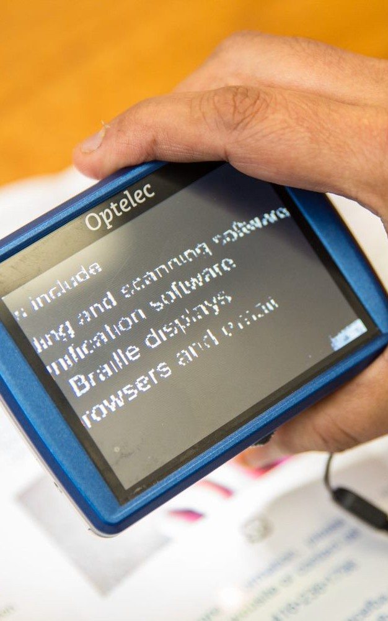
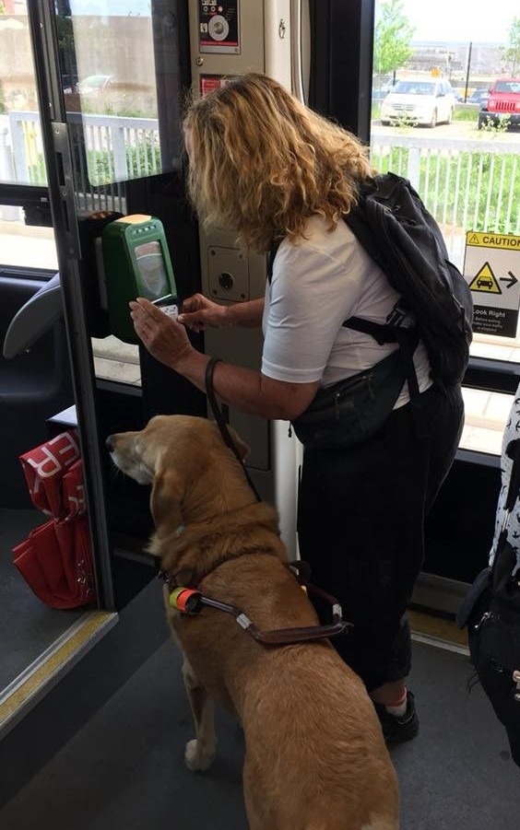
Our small team of highly skilled, multi-disciplinary staff are able to work in a coordinated way with clients, in their neighbourhoods, and often intermittently over time as their circumstances change, to help them towards their desired goals. Our clients tell us that our unique approach to program delivery allows them to live more independently and participate more fully in community life.

THE CONTEXT
The environment in which Ontario Ministry of Health-funded community support organizations like BALANCE operate has changed considerably since the implementation of our last Strategic Plan in 2016. The new provincial government launched a significant restructuring of the Ontario health care system in the fall of 2018. The primary goal of the reform is to create an integrated care delivery system that is based in community geographies, or sub-regions within the province.
As an agency providing service across a region, rather than being neighbourhood- or sub-region based, BALANCE is in a unique position vis-à-vis the planned restructure of the system. In addition, BALANCE does not provide direct service that is related to hospital admission/re-admission, like some other community support organizations. Instead, we support persons with a specific type of disability, so that they may live more safely and independently in their communities.

THE STRATEGIC PLANNING PROCESS

The planning process was led by an ad hoc Board committee and supported by our external consultant. The process focused on identifying BALANCE’s internal strengths and areas for improvement, and the external opportunities and threats. As part of this environmental scan, we reached out to a number of key stakeholder groups for input. (See Appendix A for an overview and analysis of the input obtained from these consultations.)

Client input on how they view the impact of services received, and the value of BALANCE as an organization, was solicited through two focus groups and a telephone survey of 30 clients randomly selected from the list of those served last fiscal year. BALANCE staff also participated in a focus group to ensure we developed a detailed understanding of how they view their work, their clients and the challenges they face in meeting client needs. The staff were also actively involved in the analysis of client database information, including demographics and the details collected at intake.
Ten telephone interviews were also conducted with executives and senior managers/planners in both the vision loss rehabilitation and larger health care sectors, many of whom had worked collaboratively with BALANCE in the past. These interviews were particularly helpful in learning about external stakeholders’ views of BALANCE services, and in developing a deeper appreciation for how the restructuring process is unfolding in other parts of the health care system.
During the strategic planning process, it was decided that a thoughtful revision of BALANCE’s Vision, Mission and Values statements would contribute a strong and clear foundation on which to base our plan and operations into the future.
"BALANCE shows all blind people that we can participate in society and contribute."
WHAT WE ASPIRE TO ACHIEVE
An open world for persons who are blind or living with sight loss.
WHAT WE DO
BALANCE provides customized training and support to facilitate optimal independence and community engagement for persons who are blind or living with sight loss and who often have complex needs.
* Quotes in this document are from client focus groups and a survey conducted during the strategic planning process.
WHAT VALUES INFORM WHAT WE DO
- INCLUSION
We believe all persons have the right to equal access to the opportunities available in their communities.
- TRUST
We create an environment in which persons feel physically and emotionally safe.
- EMPATHY
We relate to each person with understanding and sensitivity to their thoughts, feelings and experiences.
- RESPECT
We approach each person with thoughtful and non-judgmental regard.
- INDEPENDENCE
We provide person-directed support to achieve each client’s goals as fully as possible.
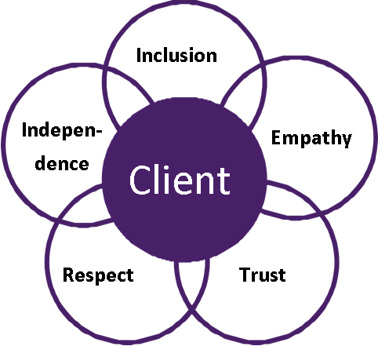
The above graphic has a central circle and is surrounded by 5 interlocking circles, the central circle says “Client”. The 5 outside circles are all connected to the “client” circle and each says one of the above value words: Inclusion, Empathy, Trust, Respect, and Independence.
PRIORITY
Ensure the sustainability of BALANCE and increase access to its specialized resources to meet the diverse and complex needs of persons who are blind or living with sight loss.
"I really like that BALANCE keeps me connected to the community."
"BALANCE understands how to be accessible for people with disabilities and be inclusive, especially for people who are isolated and face a lot of barriers."
STRATEGIES
1. Identify and evaluate the options for participating in a full and value- added way in the local health system restructuring process.
2. Develop collaborative agreements with other specialized community resources to ensure that clients’ diverse needs can be addressed.
3. Identify and explore strategic partnerships with other disability- focused provincial and national organizations.
4. Develop a comprehensive marketing plan to effectively approach potential donors, both individuals and organizations.
5. Explore feasible ways to generate revenue by marketing BALANCE’s specialized expertise to other human service organizations.
The BALANCE Board of Directors wishes to thank those who took the time to contribute their views to the development of this plan. It is our firm intention to work with determination and commitment to implement these strategies in order to secure the valued services and supports provided by BALANCE
"BALANCE facilitates meaningful involvement in the community."
"BALANCE is helpful for people like me because I gained confidence in my problem solving skills as a newcomer to Canada."
"I appreciate that I can get a hold of someone at BALANCE whenever I need help."

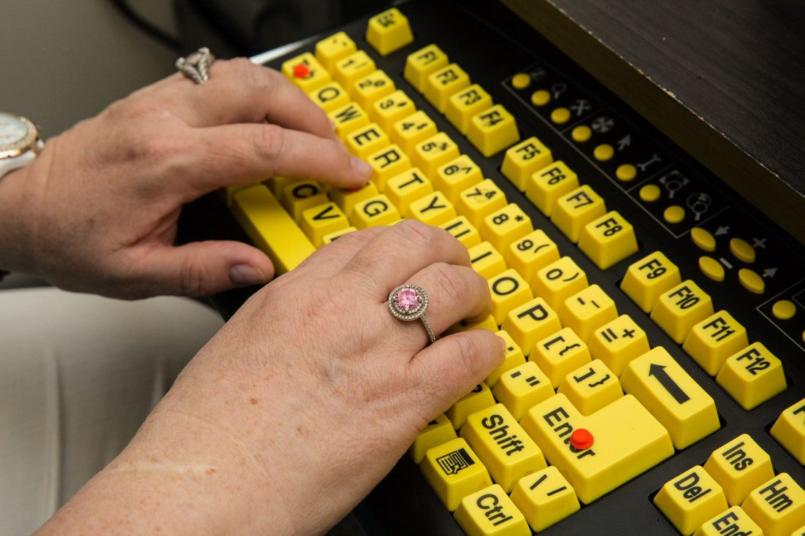
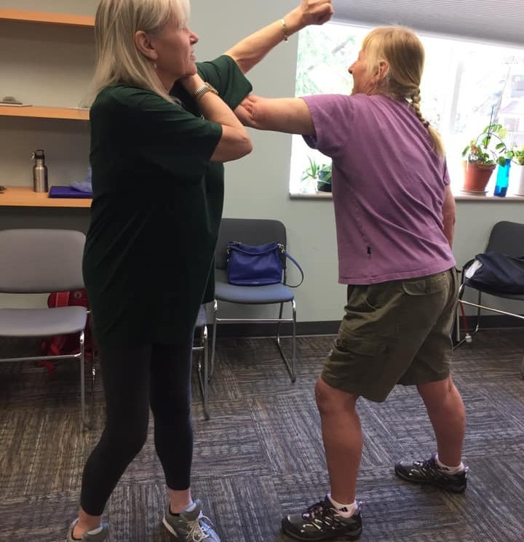
APPENDIX A
Overview of the S.W.O.T. Analysis of Stakeholder Consultations
Strengths
- BALANCE provides a “unique” vision loss service and is trusted by all who refer to them BALANCE is viewed as providing specialized and diverse services and supports
- BALANCE is able to serve persons who are blind or living with sight loss who have complex needs
- The community engagement work BALANCE does with clients is highly valued and not readily available elsewhere
- The ability of BALANCE staff to work with clients in their home communities is critical to many clients
- BALANCE’s small multidisciplinary team is integrated and uses a “whole person” approach in developing a support plan
- Clients can return to BALANCE for further service/support as needed
Weaknesses
- There is no clear and common understanding of the differences between BALANCE and the CNIB/VRC
- The historical “competition” between BALANCE and the CNIB has not been helpful to either organization
- BALANCE’s small size/budget make it particularly vulnerable in the context of the integrative restructuring of Ontario’s health care system
Opportunities
- Develop a strong and compelling case to document the value of BALANCE and how it differs from the CNIB/VLRO
- Develop local partnerships to leverage BALANCE’s resources to meet client needs
- Ensure BALANCE’s specialized services/supports continue to be available to all local OHTs Explore the possibility of collaborating with other adult disability-focused local organizations to develop a formal network that coordinates access to its services by all local OHTs
Threats
- BALANCE’s small size/budget
- The current restructuring of Ontario’s health care system
- The lack of a clear differentiation between BALANCE and the CNIB/VLRO

