ANNUAL REPORT
2020 | 2021
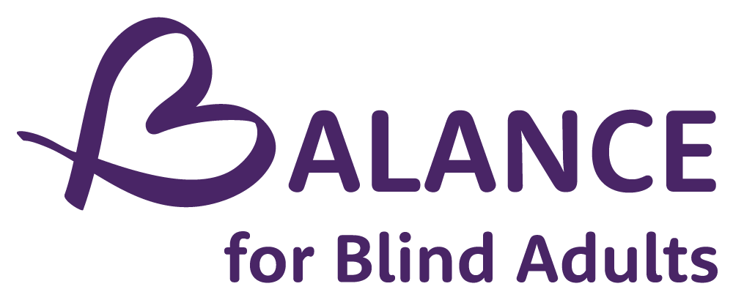

Rehabilitation services for people with sight loss.

We listen. We teach.
We support…the whole person.

From wherever you are in your journey, to wherever you may be going, we provide the services and programs you will need to get there.

Inclusion
Respect
Trust
Independence
Empathy

“Anything that BALANCE has done, they have done with the utmost consideration for the blind community."

Client response
2020 Client Feedback Survey

Land Acknowledgement

We at BALANCE for Blind Adults respectfully acknowledge that we operate, and are currently meeting on, the traditional territory of many nations including the Mississaugas of the Credit, the Anishnabeg, the Chippewa, the Haudenosaunee and the Wendat peoples. This land remains a home, gathering place and travel route for many diverse First Nations, Inuit, and Métis Peoples.
We also acknowledge that Toronto is covered by Treaty 13 signed with the Mississaugas of the Credit, and the Williams Treaties signed with multiple Mississaugas and Chippewa bands. In a spirit of reconciliation and gratitude for those who first occupied these lands, we offer thanks for the histories, languages and traditions that influence us to this day.
BALANCE’s work with blind Canadians stems from a long history of marginalization and inequity and now hinges on core values of inclusion, respect, empathy, trust and independence. We share some of this history with, and extend all our values to, members of Canada's Indigenous communities. By living and practicing these values each day, we hope to both honour and forge new connections with all residents and creatures of Turtle Island and beyond.
BALANCE Board of Directors 2020-21
Michelle McQuigge Board Chair
Bob Stark Past Chair
Dr. Keith Gordon Vice Chair
Robin Dafoe Secretary
Anne (Hurka) MacPhee Treasurer
Dr. Virginia Duff Board Member
Joeita Gupta Board Member
Darren R. Harper Board Member
Stephen Ricci Board Member
Marcus M. Song Board Member
Meenakshi Venkatesan Board Member
Celena Lee Board Support
Emily Laevens Board Support

BALANCE Staff & Contractors 2020/ 2021
Dr. Deborah Gold Executive Director
Doug Poirier Assistive Technology Instructor
George Quarcoo Assistive Technology Instructor
Chloe Thibault Reception/ Groups Coordinator
Bill Phung Orientation and Mobility Instructor/ Data Specialist
Anita Laurnitus Orientation and Mobility Instructor/ Volunteer Coordinator
Cristina Lopes Community Engagement Services
Ann Park Wellness Team Member
Shaunelle Gregory Wellness Team Member
Troy Taylor Office Assistant
Naomi Hazlett Occupational Therapist
Lisa Derencinovic Counsellor/ MSW RSW
Kristyn Lee Occupational Therapy Assistant
Beverley Murray Grant Writer
Sandy Feldman Web Designer
Margrett Weldon Client Satisfaction Surveyor
Zainab Malek AT Apprentice
Michael Sidarose AT Apprentice

Message from the Board Chair

When I wrote my message last year, BALANCE for Blind Adults and the world at large were in the middle of adjusting to a life turned upside down by COVID-19. One year later, with signs that the worst of this pandemic may actually be behind us, I’m proud to once again sing the praises of BALANCE, its staff, its board and its work for Toronto’s blind community.
While COVID-19 made it necessary for BALANCE to provide most of its services virtually throughout the year, it’s been incredible to watch the organization create new ways to serve clients. Services have expanded and adapted to the current climate, and staff kept community members feeling connected during a time of increased isolation. Our Board is also proud of the organization’s efforts to ensure and support access to the COVID-19 vaccines. I have been both moved and impressed by BALANCE’s willingness to provide concrete, hands-on support to help keep our community safe.
The pandemic, of course, has not been the only challenge to navigate in 2020-21. At the 2020 Annual General Meeting (AGM), I made a promise of BALANCE’s commitment to denouncing and combatting racism, particularly as it affects members of our community. I’m pleased to say that this work has begun. The board is keen to ensure its membership reflects the diversity of Canada’s sight loss community and is actively pursuing increased training and awareness on related issues.
I’m also pleased to announce that the board has crafted BALANCE’s first Land Acknowledgement. We will be undertaking broader consultations to make sure the Land Acknowledgement represents a meaningful move towards reconciliation and inclusion.
Our strong and dynamic Board is a group of exceptionally intelligent and talented volunteers with a wide array of professional and personal perspectives. Our Board ensures that BALANCE is guided with knowledge and grace, ensuring the organization is always there for its clients. Board members, thank you. Thanks are also due to our Board Administrative Support volunteers Emily Johansen and Celena Li. The Board wants also to thank our Executive Director and her dedicated staff team, who truly make BALANCE the unique and valuable organization that it is.
The Board wishes to thank the Ministry of Health for our core funding, and all of our foundations, sponsors and donors for helping to make this another successful year of programming and service. And finally, thank you to all our clients. Your trust in BALANCE is why we’re here and drives our every decision. Thank you for your ongoing support, and please stay happy and healthy as we hopefully turn the page on this turbulent pandemic era.
Michelle McQuigge
Board Chair 2019-2021
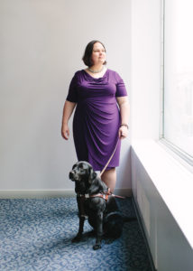Pictured: Michelle standing in a purple dress, gazing out a window to her left. A black guide dog is sitting at her feet.

Message from the Executive Director

This past year has clearly demonstrated both our strength and our flexibility as an organization, and as a community. While there were numerous difficulties and challenges for us during this year, there were also many achievements and highlights.
I want to thank the staff team from the bottom of my heart for their hard work over an extraordinary year. Even while working across distances and alone from our homes, our team became closer as we had to problem solve together.
What characterized the “BALANCEd” approach?
We were available to help. In November 2020, we conducted a client survey concerning our COVID-19 response and the support we provided. Clients told us we were there for them early on and able to help them out right away. We also began to expand entertaining and fun online experiences and events for our community.
We responded to the holistic needs of our clients.
Throughout the year, we added services to support our clients’ mental health. One major highlight was our TeleSupport Team, which supported more than 150 clients with regular check-in phone calls throughout the year, and helped to reduce isolation and meet people’s needs for community resources.
We reached out to the wider community.
Throughout the year we offered a whopping 175 group sessions online. The number and variety of groups offered meant that we expanded our reach to participants who had never used our 1:1 services.
We also were able to provide meaningful group participation to people outside of Toronto because of technology. Our reach also grew through the new community partnerships we initiated, the launch of our very successful monthly podcast, the start up of the AT Apprenticeship Program, and our vaccine engagement work.
We broke a record.
The year ending March 31, 2021, BALANCE provided service to a record 197 individuals. This represents a 95% increase from 2016, when I joined the organization. COVID-19 has challenged us all, and also opened many new doors.
However, all of the service expansion of 2020-21, combined with the demand for virtual groups, indicates we have a very bright future, and we look forward to it with excitement and a renewed sense of purpose.
Deborah Gold
Executive Director
Pictured: Deborah Gold standing against a white wall. She is smiling , and has glasses on. She is wearing a black cardigan and a grey shirt.

Selected Statistics

2020/21 2019/20

New Intakes (Clients) 42 67
Unique Individuals Served 197 167
Total Visits 1,461 1,279
Total Service Hours 1,520 1,792.5

Face to Face Service (in hours) 226
Telephone Service (in hours) 1,216
Group Sessions 175
Group Participations 769
Clients Completed Service 131

Condensed Financial Statements
2020/21 2019/20
ASSETS
Current Assets
Cash 104,040 75,493
Investments 368,265 319,585
Accounts receivable and prepaid expenses 24,398 11,048

496,703 406,126
Capital Assets

512,647 406,126

LIABILITIES
Current Liabilities
Accounts Payable and accrued liabilities 55,854 27,828
Due to Ministry of Health 62,959 6,124
Deferred revenue 24,132 8,731

142,945 42,683
Deferred capital contributions 15,944

158,889 42,683

NET ASSETS
General Fund 339,090 348,086
Colin Haines Fund 14,668 15,357

353,758 363,443

$512,647 $406,126

Condensed Financial Statements Continued
2020/21 2019/20

Summary Statement of Revenues and Expenses
Year Ended March 31, 2021

Revenues
Ministry of Health program funding 493,650 532,458
Donations and fundraising 30,005 47,669
Investment and sundry income 697 5,084
Other grants/ projects 20,806 58,567

545,158 643,776

Expenses
Salaries and Employee Benefits 408,559 417,527
Occupancy 41,677 40,103
Professional Fees 32,171 40,103
General and Operating 22,039 26,014
Communication 21,836 31,508
Training Centre and other funded expenses 6,857 7,160
Disbursement from Colin Haines fund 745 731
Fundraising 153 5,572
Other grants/ projects 20,806 58,567

554,843 604,045

Excess (deficiency) of revenues over
Expenses for the year $(9,685) $39,733
Tom Dekker Assistive Technology Achievement

At our 2021 Annual General Meeting, we announced the recipients of the first annual Tom Dekker Assistive Technology Achievement Award. These awards were created by the BALANCE Board of Directors in December of 2020 to recognize the extraordinary efforts of two students in Assistive Technology. Awardees were selected by our Assistive Technology instructors at the time.

Parnian Abdul Ghafoor
When asked about what she’s most proud of in her AT journey, Parnian said: “I feel very proud when I am preparing PowerPoint presentations, before I started my learning journey. I thought it was impossible, but I did learn it.”
Through her lessons, she has been able to use her phone more and more, accessing online banking, Zoom, Facebook Messenger, WhatsApp, and email. She mentioned that she “enjoyed navigating the blackboard, when [her] classes were online, and learning Microsoft applications.”
She said that through her hard work and determination, and after a year and a half of learning, she was able to achieve all of her goals. She also wanted to thank BALANCE staff member Cristina Lopes for pushing her to learn all of these programs so that she could get a good job.
Anna Rago
Anna Rago said that when she first met George, she didn't even know how to turn an iPad on. She went on to say: "I had no knowledge of technology whatsoever. Now I can send messages. I can send emails. I do my own banking online... I am proud of the fact that I can do these things."
When asked what she enjoyed most about her newly acquired skills, she said: "What I really enjoy is being able to communicate with family and friends online. I enjoy FaceTime with my grandchildren, sending messages to my friends, and corresponding through email."
When asked if there was anything she disliked about her AT journey, she shared that Safari wasn't her favourite to navigate, but that she would keep trying and learning.

Vaccine Rollout Support

In February 2021, as plans for the vaccine rollout began in Toronto, BALANCE reached out to our clients to chat about the vaccines, provide up to date information and vaccination booking support if needed. In total, we called over 80 clients before the end of March, and then continued to support the roll-out in concrete ways in the beginning of the 2021-22 fiscal year.
We look forward to reporting Vaccine Engagement details in next year’s annual report, including: numbers supported; production of vaccine hesitancy videos; City of Toronto vaccine engagement partnership; Ambassador activity and City of Toronto Vaccine Accessibility Task Force membership. We have been busy!

Pictured:
Staff members Cristina Lopes and Bill Phung at the MTCC accessible vaccine clinic, with masks on and face shields. They are standing in front of a multi-coloured poster with text that reads "I Got My COVID-19 Vaccine."

Thank you to our Volunteers!

2020 was a year that challenged all of us. With a global pandemic, BALANCE for Blind Adults had to quickly pivot on how we provided services and unfortunately, all our in-person volunteer support had to come to an end. Most of our volunteers continued to commit their time to our virtual programs and we also saw a growth in numbers as people started to look for new ways to give back. Throughout the pandemic, 12 new volunteers were on-boarded to assist in virtual groups like Trivia Night, Coffee Connections and reading our weekly newsletter. When the whole world was staying in, our volunteers assisted in our virtual groups that connected our clients to each other and the outside world.
Anita Laurnitus
BALANCE Volunteer Coordinator

Volunteering for BALANCE has been both rewarding and exciting. I have been providing support to the Beyond Siri workshops, monthly Let’s Get Quizzical events, and weekly Coffee Connections. BALANCE has helped me to build my confidence, my professional experience, and a sense of community. I started volunteering during COVID which I found easier with the creation of virtual roles. The most rewarding part of the virtual roles is meeting new people from all parts of the country and hearing their different stories. It is very fulfilling to provide support regardless of the distance and to put a smile on faces. From my time volunteering, I have come to know people, their stories, their cultures and learned so much about the blind community. I am very excited to continue volunteering with BALANCE and I am looking forward for what the future holds.
Savina Nankoo
BALANCE Volunteer

TeleSupport Team
In March of 2020, BALANCE for Blind Adults repositioned staff who were unable to get out to meet clients and created the TeleSupport Team. The TeleSupport team followed up with clients to see what supports were needed throughout the sight loss community during the COVID-19 pandemic and isolation period, and we did our best to connect clients with those supports. During the December holidays, this led to a community food drive, and a partnership with Feed It Forward.
When staff returned to in-person services, volunteers continued to support BALANCE’s Community Engagement Services with follow-up calls to clients.
The TeleSupport Team provided support to a total of 165 BALANCE clients, providing resources, services and a listening ear. 568 calls were made, making up 264 staff hours. BALANCE is proud of the work we accomplished, and hope that our support was able to make a difference in the lives of our clients.
Cristina Lopes
TeleSupport Lead

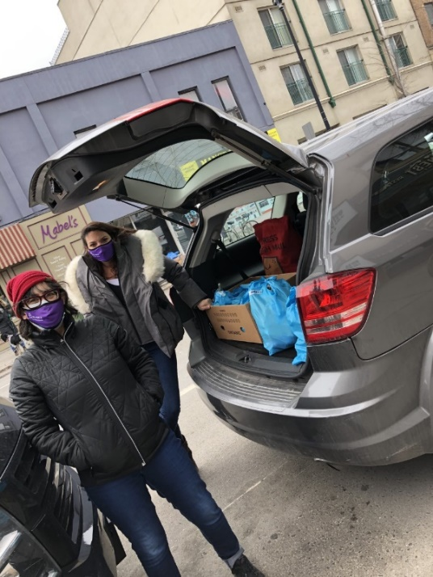
Pictured: Deborah Gold and Cristina Lopes standing outside with their purple BALANCE masks on. They are standing in front of a car trunk with boxes of food from the Feed It Forward holiday food drive.

Groups and Programs

2020-2021 marked an exciting year for groups and events at BALANCE. Our pivot to the virtual world of Zoom opened up many opportunities; not just to diversify our offerings, but to extend our reach to participants across Canada.
This year, BALANCE ran a total of 27 groups and events and served approximately 700 people in our groups.
As the pandemic took center stage in many of our lives, BALANCE first and foremost recognized the importance of addressing the wellbeing of our community by offering ongoing classes such as Yoga, Living with Uncertainty, Guided Movement and Meditation and our Sharing Space Support Group.
One-time events such as How to Assess Safety in the Home, and the COVID-19 Presentation from Toronto Public Health also helped support our clients with practical solutions and reliable information. The pivot to living virtually also meant that technology workshops and groups became a staple for staying in touch with the world. Our clients learned new skills with our Beyond Siri series, Let’s Talk Tech Computer workshops, CELA, and Microsoft Soundscape groups.
BALANCE was also able to be creative with some wonderful groups like Good Vibrations, Music Appreciation, our Creative Writing workshops, and the ever-popular Listening Stage Series delivered in partnership with Common Boots Theatre. We would also be remiss if we didn’t mention some of our other recreational groups: Let’s Get Quizzical, the Adventure Zone and Coffee Connections.
Thank you to our community partners and many volunteers for making our groups and event offerings this year so plentiful!
Chloe Thibault
Groups and Events Coordinator

Funding Partners
Thank you to the following groups and organizations for their support in the 2020-2021 fiscal year. The support of the following organizations allowed us to offer a variety of services and programs to our clients.

Accessible Media Inc. (AMI)
The Arthur and Audrey Cutten Foundation
Service Canada/ Canada Summer Jobs
Hawkey Family
J.P. Bickell Foundation
La Fondation Emmanuelle Gattuso
LIUNA Local 183
Ontario Ministry of Health
United Way Greater Toronto (ECSF)
2020/ 2021 Community Partners
BALANCE is grateful to the following organizations for their partnership in our community and beyond.
We are stronger together.
ABC Life Literacy
Adventures CCB
AEBC
CCB Toronto Visionaries
CCB National
Centennial College Occupational Therapy Assistant Program
Centre for Independent Living Toronto (CILT)
City of Toronto
CNIB
Common Boots Theatre
COSTI
Dalhousie University Master’s in Social Work Program
Davenport-Perth CHC
Feed it Forward
Fighting Blindness Canada (FBC)
Four Villages CHC
Opera Atelier
PACE Independent Living
Sprint Senior Care
St. Stephen's Community House
Storefront Humber
Toronto Public Health
Tropicana Employment Centre
University of Toronto Department of Occupational Science & Occupational Therapy
VHA Toronto
Vision Loss Rehabilitation Ontario and Canada
Volunteer Toronto
West Toronto OHT Collaborative
Woodgreen Housing Help Centre
York-Seneca Rehabilitation Services Certificate Program
2020/ 2021 Donors
BALANCE thanks our many individual donors for their contributions in the 2020/ 2021 year. Your gifts, whether small or large, have made a big difference for our clients during a very challenging year.

Jeanine Allot
Soren Antosz
Laura Barker
Robert Biggs
Julie Bot
Christy Brayley
Debbie Bryane
Janet Cane Roblin
Robin Dafoe
Dorothy de Val
Virginia Duff
Sandy Feldman
Judith Gabor
Sandra Gold
Sarah Hillyer
Terri-Lynn Hulett
Sylvia Jonas
Rahul Kaul
Mark Kim
Eleanor Lobo-Lee
Arlene Mawson
John McCleary
Beverley Murray
Mithila Pathmanathan
Cat Peever
Harvinder & Seema Puri
Christine Simpson
Jeff & Jonna Smith
Orysia Sozanski
Adam Struth
Peter Tsatsanis
Yang Wang
Anna Yin
& many Anonymous Donors

If you would like talk with us about ways you can support our organization, please call our office at 416-236-1796 extension 0, or email us at info@balancefba.org.

balancefba.org
info@balancefba.org
416-236-1796

Follow us on Social Media!
Facebook @balanceforblindadults
Instagram @balanceforblindadults
Twitter @balancefba
YouTube @BALANCE for Blind Adults

2340 Dundas St. West, Unit G-06. Toronto ON, M6P 4A9

