BALANCE for Blind Adults
ANNUAL REPORT
2021 | 2022
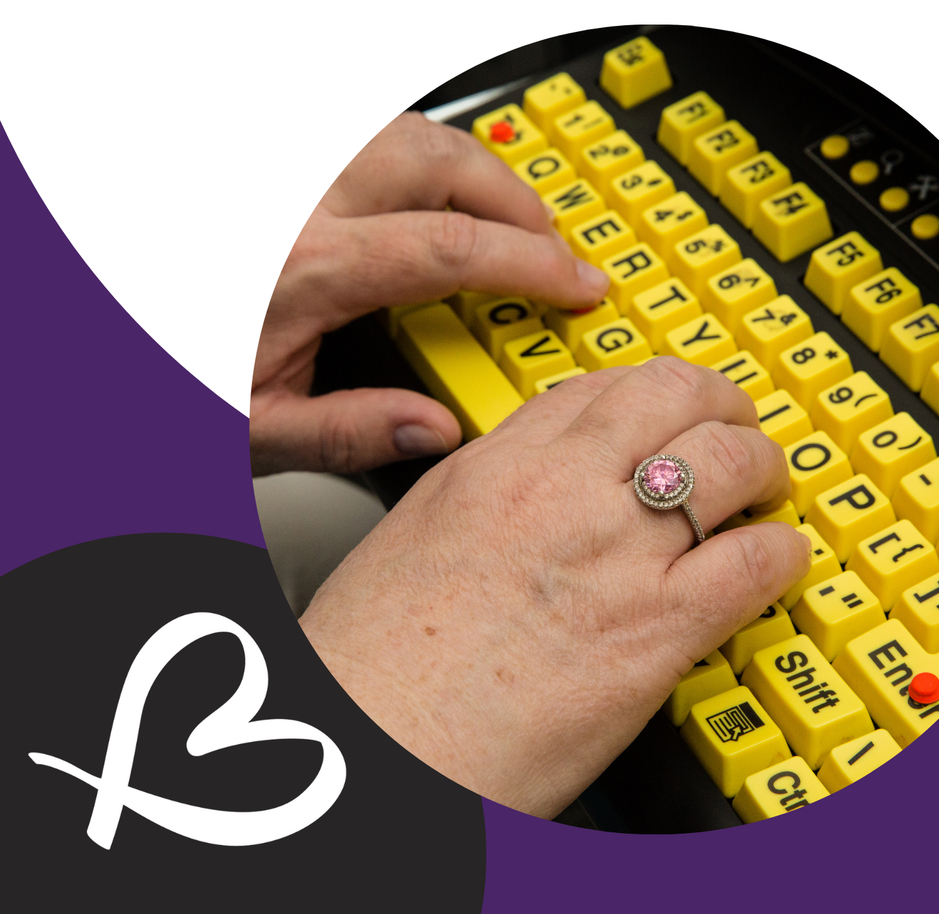
Table of Contents

Vision, Mission and Values . . . . . . . . . . . . . . . . . . . . . . . . 3
Land Acknowledgment . . . . . . . . . . . . . . . . . . . . . . . . . . . . 5
List Board of Directors, Staff, Contractors & Student . . . . . 6
Message from the Board Chair . . . . . . . . . . . . . . . . . . . . . . 7
Message from the Executive Director . . . . . . . . . . . . . . . . . 8
Selected Statistics . . . . . . . . . . . . . . . . . . . . . . . . . . . . . . . . 9
Condensed Financial Statements . . . . . . . . . . . . . . . . . . . .10
Because of BALANCE Campaign 2021 . . . . . . . . . . . . . . . 12
Tom Dekker Assistive Technology Achievement . . . . . . . . 13
Assistive Technology Apprenticeship Program . . . . . . . . . 14
Vaccine Roll-Out Support . . . . . . . . . . . . . . . . . . . . . . . . . . 15
Thank you Volunteers! . . . . . . . . . . . . . . . . . . . . . . . . . . . . 16
Groups & Programs . . . . . . . . . . . . . . . . . . . . . . . . . . . . . . 17
Funding Partners . . . . . . . . . . . . . . . . . . . . . . . . . . . . . . . . 18
2021/2022 Community Partners . . . . . . . . . . . . . . . . . . . . .19
2021/2022 Donors . . . . . . . . . . . . . . . . . . . . . . . . . . . . . . . 20
BALANCE Social Media and Contact Info . . . . . . . . . . . . . 23
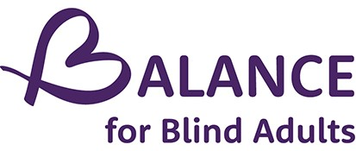

“An open world for persons who are blind or living with sight loss”
Rehabilitation services for people with sight loss.
We listen. We teach.
We support…the whole person.
From wherever you are in your journey, to wherever you may be going, we provide the services and programs you will need to get there.

Respect
Empathy
Trust
Independence
Inclusion

“Because of BALANCE I developed my ambitions. They helped me to keep pursuing my creative work and develop ideas which connected the blind and theatre community for me.

Alex Bulmer
Because of BALANCE Story

Land Acknowledgement

We at BALANCE for Blind Adults respectfully acknowledge that we operate, and are currently meeting on, the traditional territory of many nations including the Mississaugas of the Credit, the Anishnabeg, the Chippewa, the Haudenosaunee and the Wendat peoples. This land remains a home, gathering place and travel route for many diverse First Nations, Inuit, and Métis Peoples.
We also acknowledge that Toronto is covered by Treaty 13 signed with the Mississaugas of the Credit, and the Williams Treaties signed with multiple Mississaugas and Chippewa bands. In a spirit of reconciliation and gratitude for those who first occupied these lands, we offer thanks for the histories, languages and traditions that influence us to this day.
BALANCE’s work with blind Canadians stems from a long history of marginalization and inequity and now hinges on core values of inclusion, respect, empathy, trust and independence. We share some of this history with, and extend all our values to, members of Canada's Indigenous communities. By living and practicing these values each day, we hope to both honour and forge new connections with all residents and creatures of Turtle Island and beyond.

BALANCE Board of Directors 2021-2022
Keith Gordon Board Chair
Robin Dafoe Vice Chair
Michelle McQuigge Past Chair
Mark Song Treasurer
Ginny Duff Secretary
Amish Lakhani Board Member
Anne (Hurka) MacPhee Board Member
Bob Stark Board Member
Deborah Gold Executive Director/Board Member (Non-Voting)
Meenakshi Venkatesan Board Member
Martin Courcelles Board Member
Stephen Ricci Board Member
BALANCE Staff, Contractors and Students 2021-2022
Dr. Deborah Gold Executive Director
Doug Poirier Assistive Technology Instructor
Chloe Thibault Reception/ Groups Coordinator
Bill Phung Orientation and Mobility Instructor/ Data Specialist
Anita Laurnitus Orientation and Mobility Instructor/ Volunteer Coordinator
Cristina Lopes Community Engagement Services Specialist
Troy Taylor Office Assistant
Naomi Hazlett Occupational Therapy Supervisor/Podcast Host
Lisa Derencinovic Counsellor/ MSW RSW
Eve Pervin Occupational Therapy Student/Occupational Therapist
Kristyn Lee Occupational Therapy Assistant
Beverley Murray Grant Writer
Sandy Feldman Web Designer
Margrett Weldon Client Satisfaction Surveyor
Windy Ho- Li AT Apprentice
Robert Hampson AT Apprentice
Minette Samaroo AT Apprentice
Fazia Ackbarali Yoga Instructor
Dan MInchom Music Appreciation Instructor
Jenny Glostein Adventure Zone Facilitator
Alex Bulmer Vocal Coach/Creative Writing Teacher
Jess Watkin Creative Writing Teacher
Jeffrey Rainey Podcast Producer
Ramya Amuthan Podcast Guest Host
Message from the Board Chair

The past year has been another challenging one for the world in general and for BALANCE for Blind Adults as the COVID-19 pandemic continued to rage. Last year we reported on how the Executive Director and her staff at BALANCE had pivoted to take care of the special needs of our clients. I’m proud to be able to say that the dedication of our staff has continued to make a difference in the lives of our clients this year as they continued to face the challenges presented by the pandemic. The BALANCE team was there for our clients as they continued to deliver on BALANCE’s core value of meeting the needs of the whole person in delivering services to our clients.

Having pivoted to the provision of services online and via telephone, BALANCE met a wide variety of needs of our clients that were precipitated by the pandemic. Through regular contact with all clients, our staff were able to ensure that people had access to necessary food and medicines; that they were able to maintain regular social contacts with others; and were able to ensure that all clients were doing well through regular check-in phone calls. In addition, BALANCE undertook an active vaccine campaign that resulted in 98% of our clients being fully vaccinated. In many cases our staff directly assisted clients in getting to the vaccine clinics. At the same time, the normal services provided by BALANCE staff such as Orientation and Mobility training and Assistive Technology training continued to be delivered as before.

I would like to thank all members of our incredible board for their dedication over the past year. Sadly, we bid farewell to Anne MacPhee who will be retiring from the board and to Saidat Lawal, our board administrative services volunteer, who will also be leaving us in the next couple of months. Thanks to you both for all the time and support you have given BALANCE. I would like to welcome Martin Courcelles and Amish Lakhani back to the board after a short absence. We are delighted that you are back with us.

To our Executive Director, Deborah Gold, and her amazing staff, I would like to extend the thanks of the board and congratulate you all for what you have achieved in the past year under difficult circumstances. I hope the next year will enable us to return to a more normal life and a more normal way of delivering our services.
I would also like to thank the Ontario Ministry of Health for our core funding as well as all foundations and donors who have assisted us in our mission. And, finally, a big “thank you” to all our clients who worked with us to help meet the challenges presented by the pandemic.

Keith Gordon, Board Chair
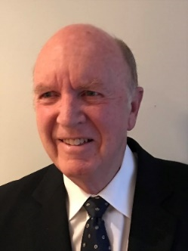Pictured: Headshot of Keith wearing black suit and tie
Message from the Executive Director

While 2021-2022 might be thought of as the year of “against all odds” for BALANCE, this past year exemplified going above and beyond and truly showing the world what it means to be small and mighty.

We began the year with our ambitious vaccine engagement program; we partnered with Toronto Public Health, participated in the City-funded Vaccine engagement collaboration with Centre for Independent Living Toronto, and became an active member of the City’s Vaccine Accessibility Task Force.

Also early last year, we embarked on the very positive step forward of a Digital Transformation Project with the amazing pro bono contribution from E-Y Ripples program and leadership from our Board team.
Challenged to examine our approaches more closely, we are proud that we were able to deliver on the promise of implementing a Diversity, Equity and Inclusion policy and Anti-racism training was provided to staff and management throughout the year.

In the interests of seeking a future home for our headquarters, we joined a group of community services and dance companies, to apply to the City to co-habit/co-locate at Bloor and Dufferin, we won this bid!

In early 2022, we hired a new producer for our Living Blind Podcast. The podcast has grown by 40% in listenership and the number of countries in which we have been played is now over 20.
In October 2021, we brought back our astoundingly successful Because of BALANCE campaign.

On the service side, we grew and strengthened the AT Apprenticeship Program with 3 committed Apprentices. We believe this program is creating exciting possibilities and changing lives. We also continued to strengthen our other services with professional development opportunities for staff members.

We wrapped up the year in style, being recognized with the CCB President’s Award, commending BALANCE for all of our achievements over the years, and in particular, during the pandemic.

I want to thank all the hard-working volunteers, Board members, clients, and staff, apprentices, students, and contractors, as well as our donors, corporate sponsors, and community partners.
Deborah Gold, Executive Director
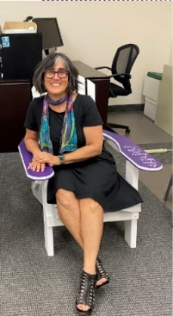Pictured: Deborah Gold sitting on a CNE BALANCE Muskoka Chair. She is smiling, and has glasses on. She is wearing a black dress and a colorful scarf.

Selected Statistics

2021/22 2020/21

New Intakes (Clients) 56 42
Unique Individuals Served 162 197
Total Visits 1,166 1,461
Total Service Hours 1,486.5 1,520

Face to Face Service (in hours) 847
Telephone Service (in hours) 639.5
Group Sessions 191
Group Participations 1251
Clients Completed Service 70

Condensed Financial Statements
2021/22 2020/21
ASSETS
Current Assets
Cash 29,478 104,040
Investments 409,827 368,265
Accounts receivable and prepaid expenses 12,121 24,398

451,426 496,703
Capital Assets

462,055 512,647

LIABILITIES
Current Liabilities
Accounts Payable and accrued liabilities 32,270 55,854
Due to Ministry of Health 61,120 62,959
Deferred revenue 17,275 24,132

110,665 142,945
Deferred capital contributions 10,629 15,944

121,294 158,889

NET ASSETS
General Fund 326,079 339,090
Colin Haines Fund 14,682 14,668

340,761 353,758

$462,055 $512,647

Condensed Financial Statements Continued
2021/22 2020/21

Summary Statement of Revenues and Expenses
Year Ended March 31, 2021

Revenues
Ministry of Health program funding 544,257 493,650
Donations and fundraising 45,895 30,005
Investment and sundry income 1,629 697
Other grants/ projects 60,088 20,806

651,869 545,158

Expenses
Salaries and Employee Benefits 466,578 408,559
Occupancy 41,162 41,677
Professional Fees 29,646 31,171
General and Operating 17,641 22,039
Communication 27,644 21,836
Training Centre and other funded expenses 3,509 6,857
Disbursement from Colin Haines fund - 745
Fundraising 5,695 153
Other grants/ projects 60,088 20,806

664,866 554,843

Excess (deficiency) of revenues over
Expenses for the year $(12,997) $(9,685)

Because of BALANCE Campaign 2021

"Because of BALANCE I always feel connected to and supported by my community." - Joseph.

We were so thrilled to have the Because of BALANCE campaign return in 2021. We had the support of 17 fundraisers, all sharing their story of how their life was improved "Because of BALANCE". Each person had their own fundraising page, many with customized videos also telling their own story.
Together with the help of their family and friends, these incredible individuals raised over $14,000 for BALANCE, and with an end of campaign matching donation, we raised a total of $24,000! These donations ensure the programs and services at BALANCE remain available to the community at no charge and our programs meet everyone where they are on their vision loss journey; monies raised in our fall campaign fund programs well into the following year.
Please consider joining us for the 2022 Because of BALANCE campaign, every dollar raised is significant, and will make a difference for people with sight loss. To learn how you can help, email us at info@balancefba.org.
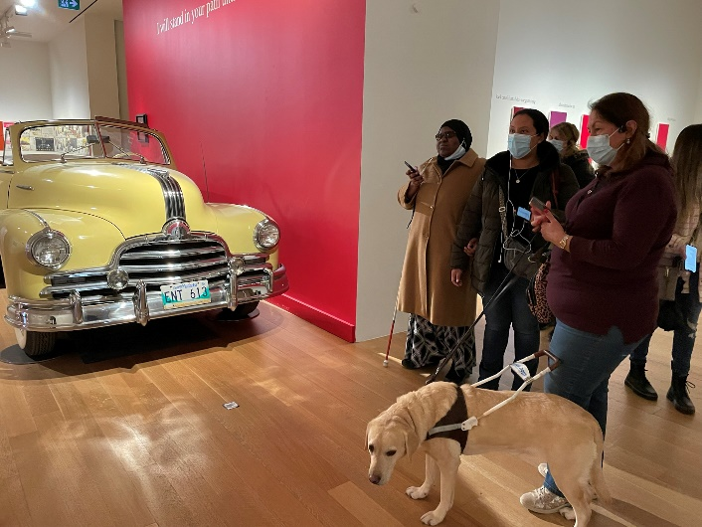
Pictured: Clients of BALANCE with one of our Orientation & Mobility Specialist in Art Gallery of Ontario

Tom Dekker Assistive Technology Achievement
These awards were created by the BALANCE Board of Directors in December of 2020 to recognize the extraordinary efforts of two students in Assistive Technology. Awardees are selected by our Assistive Technology instructors and Apprentices, as a team, and adjudicated as a team facilitated by the Executive Director.

Susanna McCleary
When asked about what she’s most proud of in her AT journey, Susanna said: “I was due to take a course in Music and Healing and it involved a lot of reading materials so Doug helped me with getting the books on Bookshare. This involved using my phone and Voicedream Reader.”
She mentioned that with Doug and Ryan’s help, she was able to gain familiarity and expertise in using Word on her MacBook. She was also able to master navigating through her Mail App, and BALANCE website.
Overall, Assistive Technology seemed to be her strength, although there are couple of things she did not manage to master, her overall experience with BALANCE’s AT training was beneficial.
She proved that she is more than ready for the challenge.
Mohamed Hassan
When asked what he has learned from the instruction, Mohammad said, “I learned a lot of things, since I came to BALANCE. Before I barely know anything about computer, but throughout my journey I gained expertise on it. I learned how to do document attachment, change file format, copy and paste text, send emails and transfer files from computer to USB.

Mohammed is proud of his accomplishment. He mentioned that through the AT program, he was able to learn the things mentioned above at the comfort of his own home, leading to more independency.

He commended his instructors, Doug and Robert, for their undivided support throughout his journey. He mentioned that both have been very patient with him.

Assistive Technology Apprenticeship Program
In 2020, BALANCE had launched our Assistive Technology Apprenticeship Program, and in this past year, we grew and strengthened it with 3 committed Apprentices. One of the apprentices, Windy Ho-Li began with the program in June 2021, and has successfully completed the 250 hour program.
Windy has grown so much through our AT apprenticeship Program. It has molded her to become a better version of herself.
At the Annual General meeting held last June 2022, Windy spoke firsthand about her AT journey:
“Before I joined the program, I had low self-esteem and I was not confident in what I could do. I often feel shameful as a person with low vision and I struggled to ask for help. I also find it difficult for others to understand and I fear other’s judgment. I was concerned and sometimes hid the fact that I needed to use screen reader, magnification and other adaptive technology. With the guidance of our Assistive Technology lead, Doug Poirier, I gained the knowledge of using extended programs that I never knew before. Throughout the program, not only did I learn the skill set to work with technology, I also learned to work with my disability, and to encourage others with similar challenges. As I grew in my self-confidence and independence, I gained patience and empathy, towards others’ needs. I can testify that my capability is beyond my disability. Even though my disabilities are challenging at times and I have unique needs, through this apprenticeship program, I learned to love myself as I discover my potential to serve those around me.”
Indeed, this program enabled Windy to step out of her comfort zone...to discover more of her potential and to push herself to her limits. She added, “I hope that you too can know that while your ability is limited by our sight loss, your weakness is also what makes you strong! Thank you again to BALANCE for Blind Adults and my clients who allowed me to participate in this wonderful apprenticeship program.”

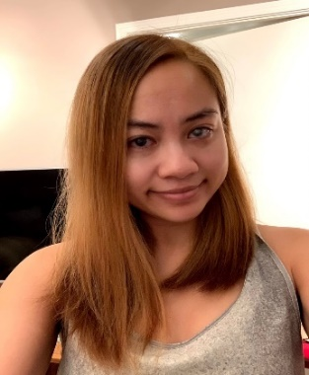

Pictured: Windy Ho-Li is smiling into the camera.
Vaccine Rollout Support- A Little (Organization) Goes a Long Way
In February 2021, as plans for the vaccine rollout began in Toronto, BALANCE reached out to our clients to chat about the vaccines, provide up to date information and vaccination booking support if needed. In total, we called over 80 clients before the end of March, and then continued to support the roll-out in concrete ways until March, 2022. In the summer of 2021, BALANCE supported over 25 clients in addition to other members of the community at accessible vaccine clinics hosted by Toronto Public Health and the City at: Metro Toronto Convention Centre and The Crossways. BALANCE was also proud to create a hand-out on sighted guide for all vaccine clinic staff and volunteers, distributed by Toronto Public Health. In addition, we provided the following educational and informational supports to our community on an ongoing basis:
- In June of 2021, BALANCE produced 2 excellent videos to encourage vaccination, and they were shared widely by other organizations
A Way Forward Part 1: https://www.youtube.com/watch?v=VXrgMI5Hklw
A Way Forward Part 2: https://youtu.be/tVNqMMPJI0Q
- Representation on the City of Toronto Vaccine Accessibility Task Force. As such, BALANCE was the representative for our community at several Accessible Vaccine Clinics hosted by Toronto Public Health and the City. Click here to hear the shout out to BALANCE from Mayor John Tory https://youtu.be/agkvQAF5Bs8.
- Partnered on a Vaccine Engagement grant for people with disabilities, with the Centre for Independent Living Toronto, and we were the designated ambassador for vaccines for blind persons in the City. We were proud to assist so many with knowledge and instrumental support in obtaining their vaccines.
Pictured: Poster advertising Super Supportive and Accessible COVID-19 Vaccine Clinc, January 2022
Thank you so much to our Volunteers!

2021 was a year that challenged all of us. With a global pandemic, BALANCE for Blind Adults had to quickly pivot on how we provided services and unfortunately, all our in-person volunteer support had to come to an end. Most of our volunteers continued to commit their time to our virtual programs and we also saw a growth in numbers as people started to look for new ways to give back. Throughout the pandemic, 12 new volunteers were on-boarded to assist in virtual groups like Trivia Night, Coffee Connections and reading our weekly newsletter. When the whole world was staying in, our volunteers assisted in our virtual groups that connected our clients to each other and the outside world.
Anita Laurnitus
Volunteer Coordinator

Signing up to volunteer at BALANCE for Blind Adults has left me feeling proud, included, and happy. I have been part of different groups and workshops where I plan and co-facilitate sessions for adults living with complete or partial sight loss, promoting social connectivity and ensuring psychological wellbeing amidst COVID-19. It has been truly meaningful to get to know new people, communicate with them, and listen to their stories. I am very thankful for the team that trained me to be an impactful BALANCE volunteer and all those that supported me through my journey at BALANCE
Myurika Sithamparanathan
Volunteer

I was impressed to learn that BALANCE has programs that help people with sight loss navigate their surroundings…unaided. They also provide counselling, assistive technology programs, OT and much more. Little wonder I just had to be a part of the BALANCE family and support the Board.
Saidat Lawal
Volunteer

Groups and Programs
This year, we were very pleased to have received a special grant from the Canadian Healthy Communities Initiative (CHCI) to support extensive group programming during the pandemic. Together with generous donations, this funding focused on staying connected and reducing social isolation experienced by so many members of our community. We were able to provide 18 courses, events and workshops in 2021-22.
Undeniably, we’ve all, to varying extents, experienced distress during the pandemic. One of BALANCE’s priorities has been to ensure the physical and mental well-being and safety of our community. To this end, BALANCE offered ongoing virtual group activities such as Yoga, Self-Defense, and our Sharing Space Support Group.
BALANCE continued to provide good quality services, aligned with our one-to-one programs, to help clients improve their skills amidst the pandemic. The commitment was greatly evident through our workshops like Elastic You-Resilience Workshop, Up Skills and the White Cane Repair Workshop.
The pivot to living virtually also meant that technology workshops and groups became a staple for staying in touch with the world. Our clients learned new accessibility skills and techniques with our Beyond Siri series, and BlindSquare event at the Art Gallery of Ontario.
BALANCE also unleashed the creativity of our clients through wonderful groups such as Creative Writing, Good Vibrations Vocal Coaching, the Listening Stage, Communication is Key, Music Appreciation and Storytelling. And of course, fun at BALANCE wouldn’t be complete without the recreational sessions: Let’s Get Quizzical, the Adventure Zone and Coffee Connections. These groups/events provided social routine and connection in a time of extreme continuing isolation and anxiety.
Thank you to our generous community partners, Because of BALANCE fundraisers and donors, and many volunteers for making our groups and events possible this year!
Ronashelle Coro
Communications Coordinator
Funding Partners
BALANCE would like to thank our 2021-22 funding partners who make possible our work on behalf of our community." In addition to our core funding from the Ontario Ministry of Health, we are grateful to:

Accessible Media Inc. (AMI)
The Arthur and Audrey Cutten Foundation
Canada Healthy Community Initiatives
CIBC Foundation
The George Lunan Foundation
Service Canada/ Canada Summer Jobs
LIUNA Local 183
Toronto Foundation-Vital Signs Grant
United Way Greater Toronto (Community Program Grants)

2021/ 2022 Community Partners
BALANCE is grateful to the following organizations for their partnership in our community and beyond.
We are stronger together.
ABC Life Literacy
Accessible Media
AEBC
CCB Toronto Visionaries
CCB National
Centre for Independent Living Toronto (CILT)
City of Toronto
CNIB
Common Boots Theatre
COSTI
Davenport-Perth CHC
Fighting Blindness Canada (FBC)
St. Stephen's Community House
Storefront Humber
Toronto Metropolitan University, Bachelor of Social Work Program
Toronto Public Health
University of Toronto Department of Occupational Science & Occupational Therapy
Vision Loss Rehabilitation Ontario
Volunteer Toronto
West Toronto OHT Collaborative
Woodgreen Housing Help Centre

2021/ 2022 Donors
BALANCE thanks our many individual donors for their contributions in the 2021/ 2022 year. Your gifts, whether small or large, have made a big difference for our clients during a very challenging year.

Tammy Adams
Cam Algie
Jeanine Allot
Tiffany Antosz
Canan Janet Atli
Munire Armstrong
Neena Avery
RABIA Azim
Bani Bakhshi
Robert Biggs
Eleanor Hykie Ballett
Girish Bansal
Lauren Barclay
Tecumseh Barr
Anirudh Bhatnagar
Dr. Lorne Berman
Isaac Berman
Rachel Berman
Karoline Bourdeau
Penny Bradshaw
Laurie Brager
Christy Brayley
Debbie Bryane
Barbara Bulmer
Shauna Burke
Judy Caldwell
Kyle Carpenter
Frances and Daniel Chang
Cathy Charby
Reva Chaudhary
Abigail Cheung
Elizabeth Cochrane
Shirley Cornish
Mena Costandi
Estelle Cote
Robin Dafoe
Sule Dalan
Dorothy de Val
Jennifer Dillon
Sabine Disumma
Evelin D'Sousa
Cheryl Englander
Ezgi Ertem
Mark Fahmy
Charlotte Findlay
Maria Fitton
Ben Fulton
Judith Gabor
Tomoko Gaspar
Radka Gajdosova
Jamie Gallie
Tania Gasparotto
Diana Gawel
Betty Gindi
Tisiano Giusti
Anna Gold
Sandra Gold
Srini Gollapudi
Keith Gordon
Tijana Gouda
Jennifer Griffiths
Sarah Griffiths
Adam Growe
Stacey Hassanzadeh
Sarah Hillyer
George Holovaci
Peter Huisman
Mei Hung
Bill Huot
Richard James
Nazira Janmohamed
Rahul Kaul
Burcin Kesik
Mona El Khafif
Durah Khalid
Naomi King
Teodora Kirilova
Lynn Knapp
Saidat Lawal
Judith Lawrence
Janfon Lee
Julie Lee
Danny Leung
Guixian Li
Micah Lindo
Eric Liu
Louella Lobo
Melissa Lobo
Eleanor Lobo-Lee
Chantal MacDougall
Evan Maltby
Lorin Markarian
Joanne Maxner
John McCleary
Larry McCrea
Michelle McQuigge
Lata and Roman Mistry
John Mohler
Tammy Morris
Beverley Murray
Arshil Nagji
Heino Nielsen
Jan Nieuwenhuis
Adeleke Ogunbayo
Mary Ann Oughtred
Gurjeet Paintel
Larry Palmer
Audrey Partington
Michelle Pavic
Kosta Petridis
Debbie Phillips
Doug Poirier
Cat Peever
Harvinder & Seema Puri
Sabrina Rai
Harsimran Rattan
Haleema Rauf
Kevin Rich
Lindi Rivers
Miriam Barrios-Rodiles
Raj kumar Saini
Mark Samaan
Hazin Sakin
Rustom Satchu
Jasmine Schuchardt
Nazli Sen
Cihan Seyhun
Zehra Seyhun
Michael Sidarose
Christine Simpson
Glendon Singleton-Wood
Antwan Shenouda
Rosie Smith
Susan Sorrey
Bob Stark
Greg Stark
William R. Stark
Nicki Starkes
Ken Sudhues
Stenton Susan
Jennifer Tan
Azim Tarmohamed
Azize Celik Topal
Beril Topcu
Brian Traquair
Peter Tsatsanis
Mahide Nur Tumok
Münevver Tuncer
Vanessa Tunney
Stephanie Vordemberge
Bernadette Walsh
Andrea Wenzel
Crystal Whelan
Megan Whelan
Margaret Williams
Katie Witzell
Jason Wong
Rachel Wong
Ellen Yamasaki
Amanda Yao
Joseph Yeung
Kenneth Yuen
Visal Zehra mohammadzadehnamvar
Viviana Zea

& our many Anonymous Donors!

If you would like talk with us about ways you can support our organization, please call our office at 416-236-1796 extension 0, or email our Development Officer, Deanna at d.carruthers@balancefba.org.

“Because of BALANCE, I have overcome barriers to communication and feel even more connected with friends and family”

Quassim
Because of BALANCE Story 2021
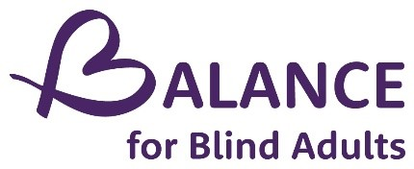

balancefba.org
info@balancefba.org
416-236-1796

Follow us on Social Media!
Facebook @balanceforblindadults
Instagram @balanceforblindadults
LinkedIN @BALANCE for Blind Adults
Twitter @balancefba
Youtube BALANCE for Blind Adults - YouTube

YouTube @BALANCE for Blind Adults
2340 Dundas St. West, Unit G-06. Toronto ON, M6P 4A9

