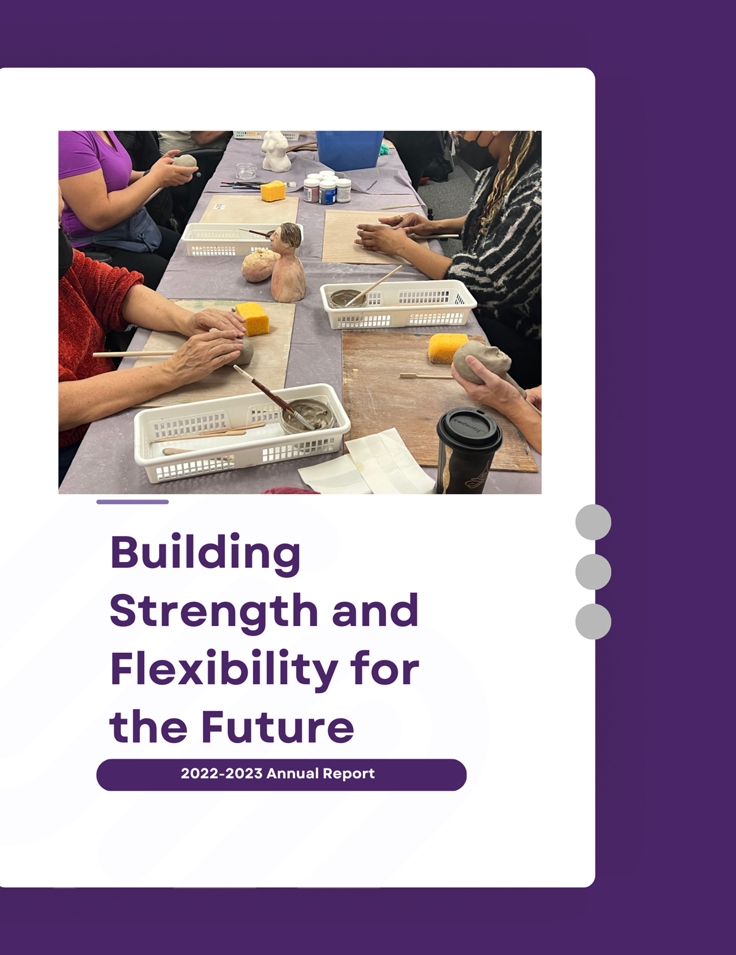
Contents
03 A Year of Impact and Innovation
04 Vision, Mission and Values
05 Impact
06 Assistive Technology Apprenticeship Program & Tom Dekker Assistive Technology Awards
07 Pre-Employment Program
08 Groups and Events
09 Living Blind Podcast 2022-2023
10 Because of BALANCE Campaign 2022
11 Volunteers Make a Difference
12 Funding Partners & Community Partners
13-15 BALANCE Staff Directory
16 Condensed Financial Statements
17 2022-2023 Donors
21 Land Acknowledgement
22 Contact Information
A Year of Impact and Innovation
BALANCE for Blind Adults spent 2022-23 re-assessing what we do and how we do it, so we could focus on re-tooling for a different kind of program delivery future. This year we strengthened our governance and operations, implemented new initiatives to meet more clients’ needs in a changing world, developed fiscal strength and flexibility, and a strategic roadmap to follow over the coming years.
In 2022-23, we once again achieved our 4 year Accreditation certificate from the Canadian Centre for Accreditation (CCA). Of note was the positive response to our approach to service: “While many organizations pay lip service to the phrase “client centred service,” we found that BALANCE truly lives this value, both in terms of the work and the philosophy.” Our commitment to centering client needs was clearly observed by the accreditors.
While all our programs deserve special mention, we want to highlight two in particular here. The Assistive Technology (AT) Apprenticeship program completed year 2 and graduated our first three AT Apprentices. All of our program grads have achieved their goals. Two new Apprentices joined the program in the fiscal year. We are so proud of the reach and growth of this initiative. In September, 2022, United Way Greater Toronto recognized our proposed Pre-Employment Program as “outside of the box thinking” and funded it for 2.5 years. We trained our first cohort in February, and developed our inclusivity training package for community service providers. We are so proud of this.
This year also represented substantial growth in grants and donations revenue, building on the generous grant from Ontario Health, and demonstrating the respect we have gained, the belief in our demonstrated values, our innovation and collaborative approach, and the empowering opportunities we provide to clients.
Our Board, staff and volunteers have all contributed substantially to another successful and productive year and we thank them for their hard work and commitment to building the strong foundation we need for a future of growth, so that we can help more people in more places, more of the time. The roadmap for this new strategy was yet another achievement of the past year, and we are ready now to move forward with our long-term goal to share our innovations more widely, creating a more open world for people living with sight loss wherever they may be.
Keith Gordon- Board Chair
Deborah Gold- Chief Executive Officer
Vision, Mission and Values
“An open world for persons who are blind or living with sight loss”

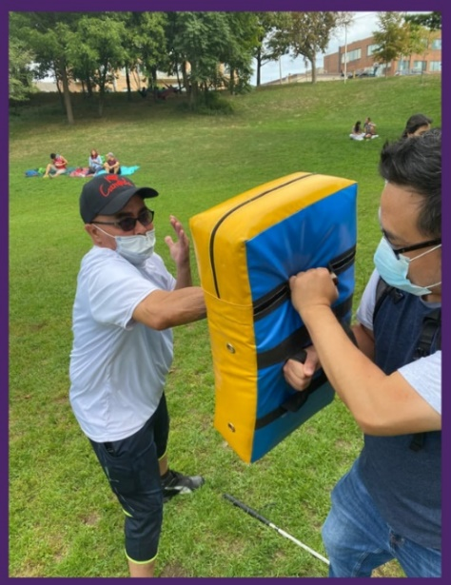
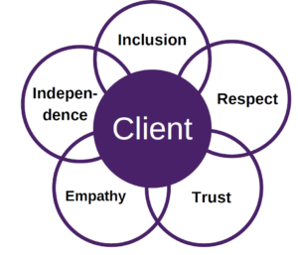
A
BALANCE provides customized training and support to facilitate optimal independence and community engagement for persons who are blind or living with sight loss and who often have complex needs.

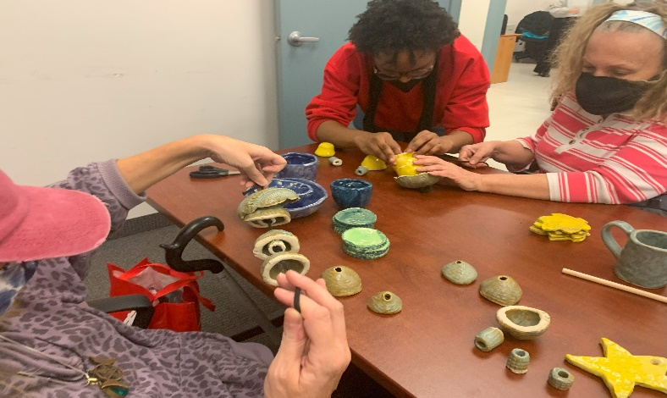
Impact

- 52- New Intakes
- 139- Unique Individuals Served
- 1190- Total Client Visits
- 62- Group Sessions
- 293- Group Participants

Assistive Technology Apprenticeship Program
Photo description: A client practicing a self-defense technique with Bill (O&M instructor)

Launched in late 2020, the Assistive Technology Apprenticeship Program works to enhance technology skills while teaching skills to others, thereby providing a paid employment experience. Apprentices learn, BALANCE gains a valuable diversity of teaching skills, technology knowledge and personal perspectives, and clients are fully supported. Through this program, BALANCE is improving job prospects for people who are blind. We thank our program sponsors CIBC Foundation and HumanWare for helping to make this program possible.

Tom Dekker Assistive Technology
Achievement Awards
Awarded annually by BALANCE, the Tom Dekker Awards recognize 2 deserving BALANCE participants who have shown great improvement in their technology skills during the course of the previous year.
Tom Dekker was a Rehabilitation Teacher and an AT instructor at BALANCE/ He retired in 2011-12 and moved to Victoria, B.C. Since his retirement, he returned to BALANCE to lead AT training forums. Tom passed away in 2020 and we created this award to honour the teacher that he was, and his memory. He was truly a character respected by both clients and colleagues.
We heartily congratulate this year's winners Robin Skeates and Hussein Abdalla.

Pre- Employment Program (PEP)

The Pre-Employment Program is a 5-week training program that works to assist blind and partially sighted adults in their search for employment. The program focuses on a variety of topics, such as communications skills, remote work, networking, assistive technology and issues around disclosure and self-advocacy. The program helps participants navigate Toronto employment service providers and opportunities, and supports those providers to accommodate. participants with sight loss.
Reactions
“I am glad I took this program. It helped me to realize a few things about myself and what I do right and wrong in my job search.”

“I felt that this program was well constructed, informative and very comprehensive. I have started to recommend it to a few friends seeking employment.”

Groups and Events

This year, BALANCE and our partners have made a significant effort to offer robust services and assistance to our clients. Among our objectives was the creation of diverse groups and events to enable our clients to connect with fellow community members, stay engaged, and acquire new skills. In 2022-23, we successfully organized 9 in-person and online groups, courses, events, and workshops.

It's undeniable that we've all experienced various degrees of distress during the pandemic. BALANCE continues to prioritize the well-being and safety of our community, both physically and mentally. To achieve this, BALANCE has introduced in person or online group wellness activities such as Self-Defense, Strength and Stability, and our Sharing Space Support Group.

Another key goal of BALANCE is to deliver high-quality services in alignment with our one-to-one programs, aimed at enhancing clients' skills. This commitment is evident through workshops like Good Vibrations, the Clay Workshop, the Self-Advocacy Workshop, and the Musical Theatre Movement Workshop.

With much of our lives shifting online, technology workshops and groups have become crucial for staying connected with the world. Our clients have acquired new accessibility skills and techniques through our Beyond Siri series. And many had a good time as BALANCE continued our Trivia Night events, where clients could test their knowledge and collaborate with others.
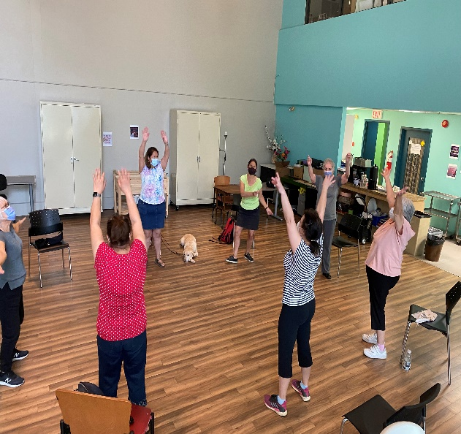
We extend our gratitude to our generous community partners, BALANCE fundraisers and donors, as well as the numerous volunteers who have made this year's groups and events possible!

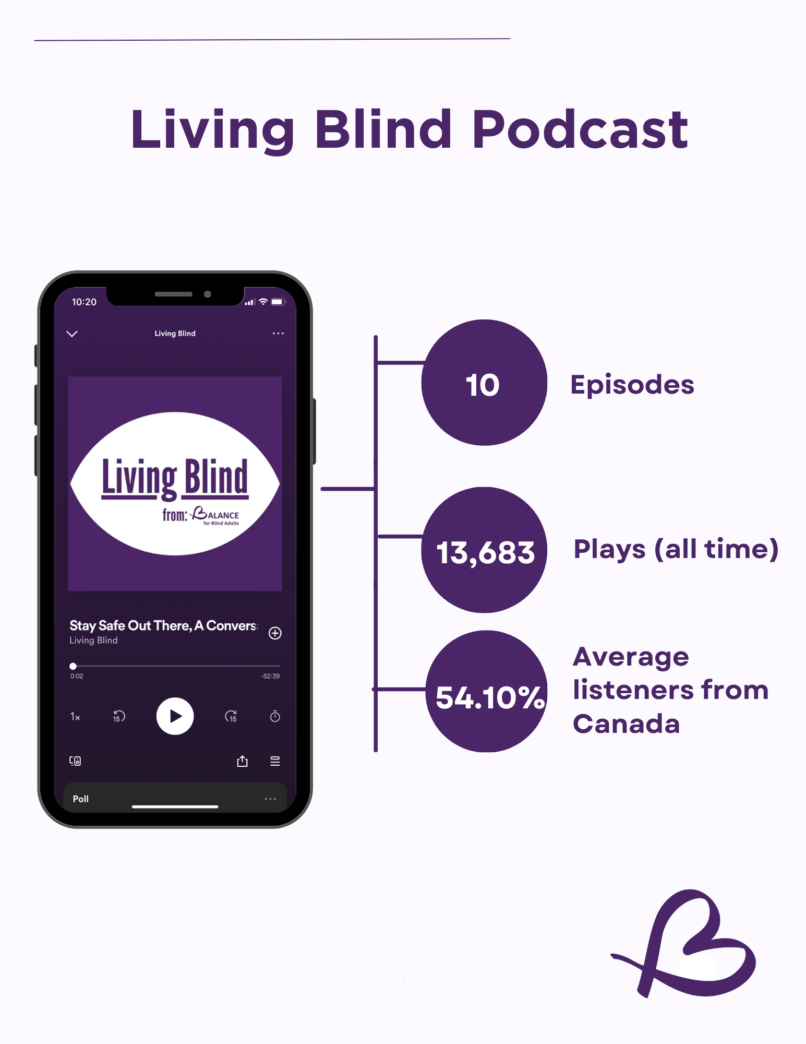
9
Living Blind Podcast 2022-2023
“Living Blind has given me the chance to hear new and refreshing stories from blind people from all walks of life. Every interview affirms the importance of making space for unique voices within the community.”
Naomi Hazlett, Living Blind Podcast Host
[Grab your reader’s attention with a great quote from the document or use this space to emphasize a key point. To place this text box anywhere on the page, just drag it.]
Because of BALANCE Campaign 2022

In 2022 our annual storytelling campaign had 29 fundraisers and raised a total of $42,013. We had 235 donations with an average donation amount of $105. In 2022 there was also an increase in social media engagement for the campaign, with the brilliant additional use of fundraiser videos. The money raised during the campaign is essential in ensuring BALANCE is able to continue offering all services and programs at no cost. And the awareness raised through the stories, is priceless.

Join us in 2023! Every fundraiser and donation makes a difference! To learn more about how to get involved please contact info@balancefba.org.
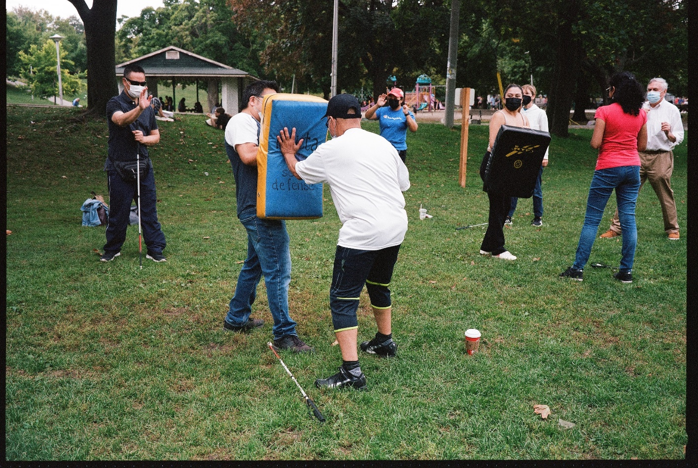

Volunteers Make a Difference!
In this past fiscal year, BALANCE got re-accredited by Canadian Centre for Accreditation (CCA) and for the first time ever, the Volunteer Program was accredited as well! This process allowed us to develop clearer processes and procedures when working with volunteers and truly formalized the program. Going forward, it will need to meet the standards of excellence that are set out by CCA. Through this process, we worked on improving communication and engagement with our volunteers.
This past year we also saw the return of in-person events and have had our volunteers assist at a variety of events such as concerts, plays, and self-defense workshops. We continue to have a strong core of dedicated volunteers who read our newsletter every week and it can be listened to by calling 416-236-1796 ext. 6. Our volunteer positions are always evolving to ensure BALANCE for Blind Adults provides seamless service to our clients and other stakeholders. I would like to thank all our volunteers who have dedicated their time and skills to make our small organization that much more mightier.

Message from Emily
Hello! My name is Emily and I have been volunteering with BALANCE for Blind Adults since 2019. Over the past 4 years, I have volunteered in a number of services which BALANCE provides, such as assisting in home visits helping clients with home-based tasks, attending BALANCE events to help with sighted guide, the AT program, and reading the weekly newsletter. One of my favourite things at BALANCE is when I get the opportunity to chat with clients and form connections. Volunteering at BALANCE has enriched my life by expanding my knowledge of accessibility issues and services which BALANCE provides to mend those gaps. I look forward to continuing to volunteer for BALANCE as it has been a very rewarding experience so far!

Funding Partners
A big thank you to our 2022-2023 Funding Partners who make our work possible!

1. Ontario Health
2. United Way Greater Toronto
3. CIBC Foundation
4. Toronto Foudnation
5. Arthur & Audrey Cutten Foundation
6. F.K. Morrow Foundation
7. LiUNA Local 183
8. Georgina Foundation

Community Partners
BALANCE is grateful to the organizations that partnered with us in 2022 and 2023.

- 4 Villages
- ABC Life Literacy
- Accessible Media
- AEBC
- CCB Toronto Visionaries
- CCB National
- Centre for Independent Living Toronto
- (CILT)
- City of Toronto
- CNIB
- Common Boots Theatre
- COSTI
- Davenport-Perth CHC
- Fighting Blindness Canada (FBC)
- George Brown College Department of
- Community Workers
- Humber College department of Social
- Services
- St. Stephen's Community House
- Storefront Humber
- Toronto Metropolitan University,
- Bachelor of Social Work Program
- Toronto Public Health
- University of Toronto Department of Occupational
Science & Occupational Therapy
- Vibe Arts
- Vision Loss Rehabilitation Ontario
- Volunteer Toronto
- West Neighbourhood House
- West Toronto OHT Collaborative
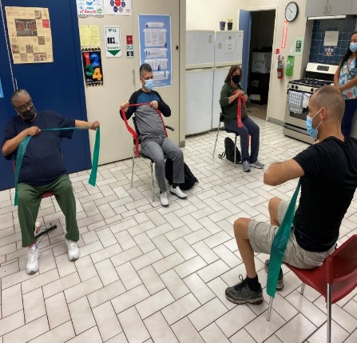
- Woodgreen Housing Help Centre

Thanks to:

Staff
Dr. Deborah Gold Executive Director
Doug Poirier Assistive Technology Lead
Ronashelle Coro Reception and Communications Coordinator
Bill Phung Certified Orientation and Mobility instructor/ Data Specialist
Cristina Lopes Program Coordinator and Community Engagement Services Specialist
Christina Peruzzi Pre-Employment Program Coordinator
Anita Laurnitus Certified Orientation and Mobility Instructor/ Volunteer Coordinator
Kiana Raeesdana Orientation and Mobility Instructor
Linda Li Occupational Therapist
Olivia Pietrzyk Adaptive Daily Living Skills Instructor
Windy Ho-Li AT Instructor
Anna Siby Summer Youth Office Assistant
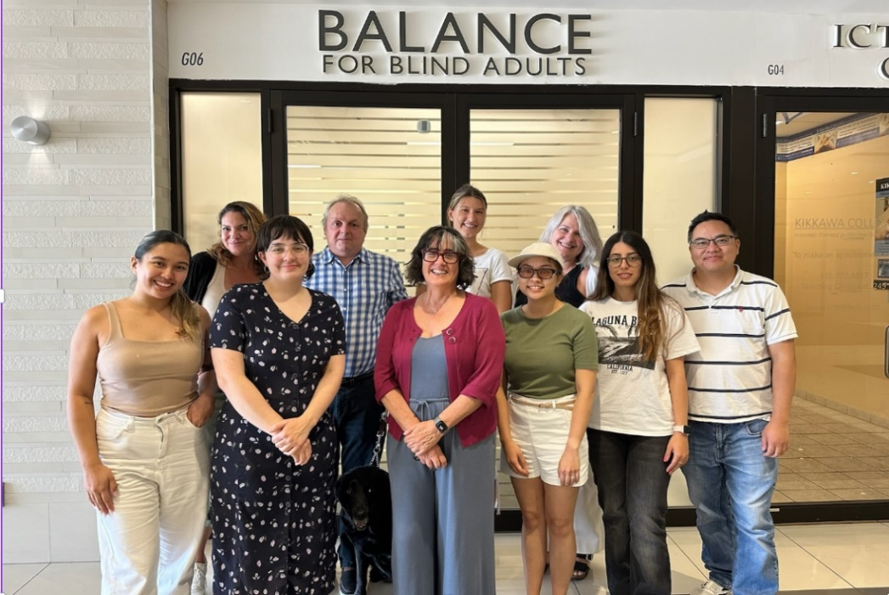
Staff Continued

Contractors:
Naomi Hazlett Podcast Host
Jeffrey Rainey Podcast Producer
Lisa Derencinovic Counsellor
Eve Pervin Occupational Therapist
Kristyn Lee Occupational Therapy Assistant

Students:
Madeleine Sommerville Occupational Therapy Student
Jovane Bowen Community Worker Placement Student
Chanel Abbey Social Service Worker Placement Student

Marketing and Fundraising:
Beverley Murray Grant Writer
Deanna Carruthers Development Officer
Sandy Feldman, Website Developer
Margrett Weldon Client Satisfaction Surveyor

AT Apprentices:
Robert Hampson AT Apprentice
Minette Samaroo AT Apprentice
Diana Horani AT Apprentice
Kim Harbroe AT apprentice
Laurisa White AT Apprentice
Victoria Hernandez AT Apprentice

Board of Directors

Keith Gordon Board Chair
Robin Dafoe Vice-Chair
Michelle McQuigge Past Chair
Marcus M. Song Treasurer
Virginia Duff Secretary
Martin Courcelles Board Member
Bob Stark Board Member
Amish Lakhani Board Member
Stephen Ricci Board Member
Meenakshi Venkatesan Board Member
Wayne Yeung Board Member
Deborah Gold Executive Director/Board Member (Non-Voting)

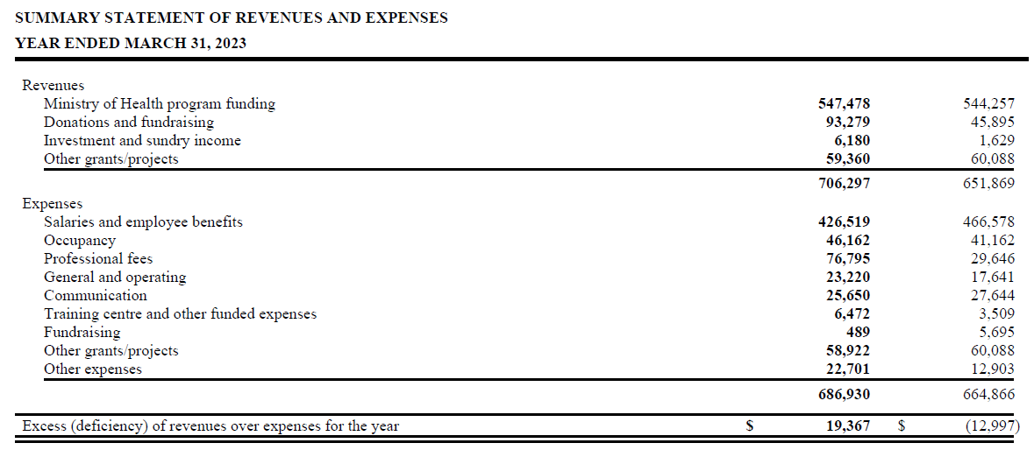
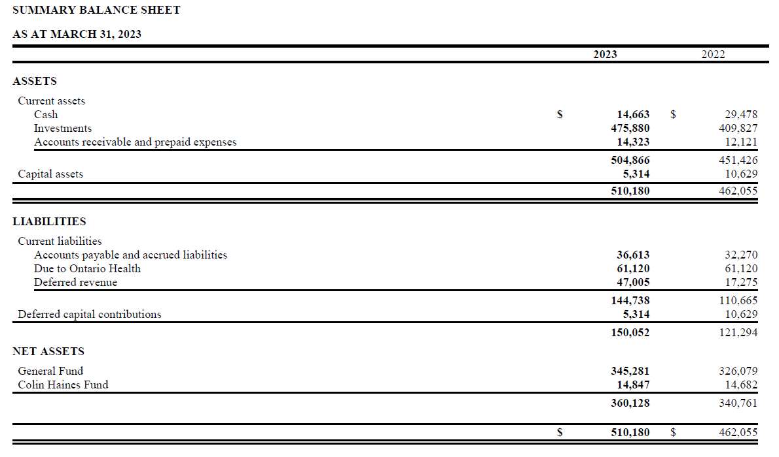
Condensed Financial Statements
2022-2023 Donors
“Our heartfelt thanks to our 2022-2023 donors”

108 Ideaspace Inc.
Adam Growe
Adela Mall
Alwiyah Shariff
Anat Nulman
Andrew Traynor
Angie Anthony
Anita Laurnitus
Anna Gold
Anna Rago
Anne Musgrave
Ari Goldkind
Ariana Christie
Aryan Aryan
Audrey Vermeer
Barbara Bulmer
Belinda Monteiro
Betty Gindi
Betty Tong
Beverley Murray
Bob Stark
Brave Leather
Brenda Kee
Brian Shaw
Bruce Baklarian
Carmen Louie
Carol De Val
Carole Simmons
Carolyn James
Carolyn Jill Leon
Catherine Anisman-Reiner
Catherine Bryant
Cathy Kilner
Charles Sue-Wah-Sing
Christian Stotzka
Christine Cushing
Christine Simpson
Cihan Seyhun
Cindy Wagman
Clare Wittmann
Clarence Baker
Collin Jarvis
Connie Woo
Cyril Elnazir
Daliah Chapnik
Danielle McLaughlin
Danny Wang
David & Esther Alerhand
David Bryane
Deanna Carruthers
Deborah Gold
Deborah Phillips
Deepesh Ahuja
Derek Grundle
Diana Horani
Diane and Jack Schuster
Diane Juzkow
Dimitris Veloudos
Don and Nita Reed Foundation
Dorothy de Val
Doug Poirier
Eleanor Ballett
Eleanor Lobo-Lee
Elisa Cardilli
Elizabeth Cochrane
Elizabeth Mohler
Emily Dy Pac
Erica Yao
Feride Seyhun
Fiona Wu
Florence Tam
Frances Lau
Frank Smith
Frederick Gonsalves
G Fuller
Gail Hutton
Gavin Herman
George Stevens
Gil Dodick
Glendon Singleton-Wood
Gloria del Carmen Lobo Singh
Gordon Brown
Grace Harlund
Grace Jones
Greta Fung
Halise Ozcan
Hany Farag
Harvinder and Seema Puri
Heather Harrison
Heather Skoll
Heino Nielsen
Humble Bumble
Ian Bryane
Ilya K.
Isaac Berman
Ivan Tom
Jaclyn Sklenka
James Brazill
Jane Wigle
Janine Mckeown
Jayme Turney

Jeffrey Rainey
Jenn Cruickshank
Jennifer Griffiths
Jessica Mina
Jill Rich
Jill Rosenberg
Jim Hurst
JMCC Maintenance and Janitorial Services
Joel Gold
Joginder Sethi
John McCleary
Julie Lee
Justin Kerswill
Karen Mootoo
Karen Rieschi
Karim Elias
Katie Woodford
Keddy Williams
Keith Gordon
Kenneth Yu
Kerstin Lueck
Kevin Shaw
Kristin Chong
Krystina Lewicki
Lana Forman
Lanjun Wang
Lata and Raman Mistry
Late King Shiu Lew
Laura Schein
Laurel-Ann Baker
Laurie Brager
Leah Cherniak
Leann Sweeney
Lee Mendelsohn
Left Turn Right Turn Ltd.
Leonard Wesley Kalison
Lin Liu
Lions Club of Weston
Lisa Laredo
Lynne Salt
Margaret Keenan
Margaret Williams
Maria-Cristina Sava
Marianne Ewasyn
Marjorie Henery
Mark Fahmy
Marrianne Bridge
Marta Swirydowicz
Martin Copeland
Mary Martin
Mary Walsh
Marylynn Feness
Matthew Stark
Mena Costandi
Merrill Swain
Michael Ghobrial
Michael Sidarose
Michelle Golfman
Michelle McQuigge
Micky Fraterman
Millie Ho
Mireille Rou
Mona El Khafif
Monica McGlynn-Stewart
Monique Dannrath
Nancy Slater
Naomi King
Nazira Janmohamed
Nick Svab
Niler Albayrak
Pamela Isaak
Pat Ebelshauser
Paul Ki
Priyanka Bakhshi
Rachel Berman
Rahul Kaul
Randi Myers
Reva Chaudhary
Rob Simms
Robert Biggs
Robin Dafoe
Rong & Jeremy Wang
Ronit Andorn-Broza
Rosie Smith
Rustom Satchu
Ryan Chin
Saidat Lawal
Sam Bucovetsky
Sandra Gold
Sandy Feldman
Sandy Lee
SenseSeeWare
Sharon Stortz
Shauna Burke
Sherry Johnson
Shirley O'Donnell
Shruti Kumari
Sibel Kuzu
Signy Pittman
Simon Barber
Sonali Gujarati
Stephanie Martin
Stephanie Montemarano
Susan Eaton-Davies
Susan Girvan
Susan Keaveney
Susan Mazan
Susan Stenton
Sylvia Langlois
Sylvia Rak
Tabitha Matheson
Tad Klupsas
Tatiana Voitovitch-Camilleri
Ted & Linda Greenberg
Terry Stortz
Terry Stortz
The Chapnik Foundation
Tiffany Precious
Toronto Foundation
Tracy Odell
True North Freight Solutions Inc.
Ummukulthum Shamte
Valerie Zawilski
Vanessa Bourget
Vijaya Munikoti
Vincent de Grandpré
Virginia Duff
Vita Matusaitis
Wanda Hamilton
William Fearn
Zahra Baptiste
Zehra Seyhun
Zheng Lu
& our many Anonymous Donors!

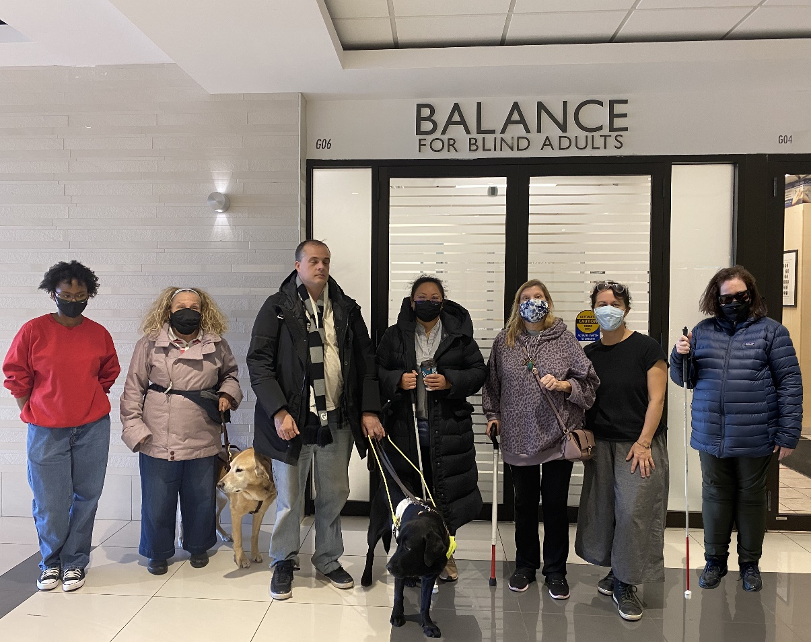

Land Acknowledgement
We at BALANCE for Blind Adults respectfully acknowledge that we operate, and are currently meeting on, the traditional territory of many nations including the Mississaugas of the Credit, the Anishnabeg, the Chippewa, the Haudenosaunee and the Wendat peoples. This land remains a home, gathering place and travel route for many diverse First Nations, Inuit, and Métis Peoples. We also acknowledge that Toronto is covered by Treaty 13 signed with the Mississaugas of the Credit, and the Williams Treaties signed with multiple Mississaugas and Chippewa bands. In a spirit of reconciliation and gratitude for those who first occupied these lands, we offer thanks for the histories, languages and traditions that influence us to this day. BALANCE’s work with blind Canadians stems from a long history of marginalization and inequity and now hinges on core values of inclusion, respect, empathy, trust and independence. We share some of this history with, and extend all our values to, members of Canada's Indigenous communities. By living and practicing these values each day, we hope to both honour and forge new connections with all residents and creatures of Turtle Island and beyond.

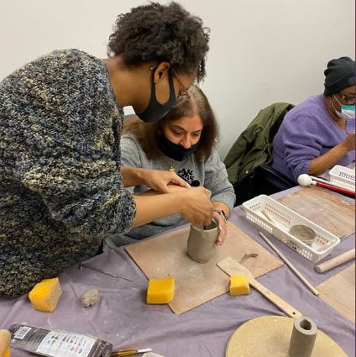
Connect with us!
416-236-1796
info@balancefba.org
www.balancefba.org
@balanceforblindadults
@balanceforblindadults
@BALANCE for Blind Adults
@balancefba
BALANCE for Blind adults

BALANCE for Blind Adults

