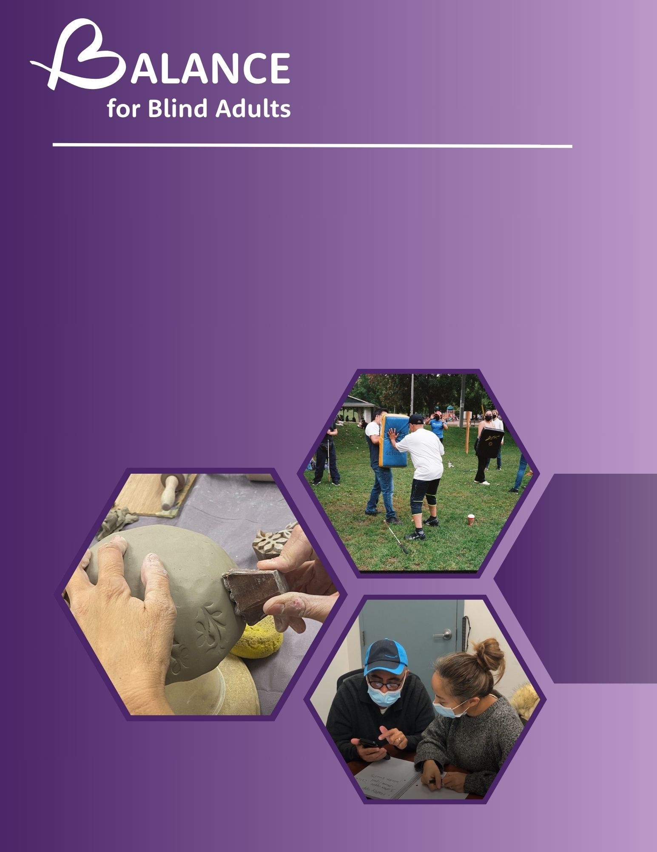
Planning for a Bold Future
In early 2022, the Board of Directors recognized the need for a bold new strategy to carry us forward for the next 5+ years. The results of our 2021 Digital Transformation Project with consultants from Ernst & Young highlighted opportunities to increase our reach to more clients and expand the service delivery area while maintaining low service delivery costs. Our primary goal at this time is to expand specific services beyond Toronto, and potentially beyond Ontario. The impact of our work indicates a need for expansion of our AT Apprenticeship Program, our mental health services, and a suggested third area of focus, the pre- employment program.
This report aims to outline research and evidence supporting our new strategic priorities for 2023-2028, a bold future for BALANCE.

Executive Summary
Our Strategic﻿ Priority remains the same:
Ensure the sustainability of BALANCE and increase access to its specialized resources to meet the diverse and complex needs of persons who are blind or living with sight loss.
Focus One
- Maintain existing excellent services in the City of Toronto

Focus Two
- Expand two of our services beyond the province of Ontario: Our Assistive Technology Apprenticeship Program and Our Mental Health Supports Program

Focus Three
- Continue to strengthen and build our United Way funded Pre-Employment Program as it is much needed and inclusion-focused

Focus Four
- Support our community, existing services, and new service through continued fund development efforts, focusing in particular on grants, donations, and corporate sponsorship.

Strategic Plan
BALANCE collaborated with Ernst & Young to brainstorm and generate ideas for the organization's future. This work led to the Digital Transformation Report, which recommended that BALANCE adapt its service delivery to thrive in the digital world and provide participant-focused services, increase the number of clients served, and expand the service delivery area where possible and sustainable. The COVID-19 pandemic in 2020-21 accelerated the adoption of remote service delivery, which proved successful and provided valuable insights.

In 2022, in response to the Board of Directors' request, Executive Director Deborah Gold created a Strategic Planning Roadmap. BALANCE engaged Catherine Bryant to lead the research and write the plan. A Strategic Planning Advisory Committee (SPAC) was convened as a focus group, to provide feedback on the findings, and to recommend strategic priorities for the next 5 years. The SPAC included key stakeholders, and experts with a variety of backgrounds, including lived experience of a visual disability. This report summarizes the research findings and recommendations based on them.

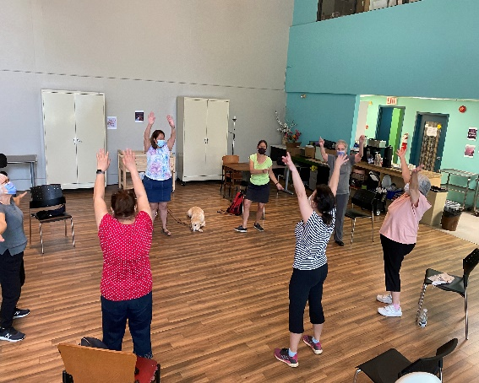

BALANCE Expansion and Remote Service Delivery
Goal

Expand BALANCE's reach nationwide through remote service delivery, starting with two primary areas of focus:
- Assistive Technology Apprentice Program
- Mental Health Support Programming, including group sessions and individualized counseling by counselors with lived experience of sight loss.
Objective

Gather feedback on BALANCE's ambitious goal and initial steps towards national expansion.
Assumptions

The vision, mission, and values statements remain valid unless identified gaps require adjustments.
There is a desire to expand services beyond Toronto and Ontario, with the ultimate aim of establishing a national presence.
Initial expansion efforts will concentrate on remote service delivery

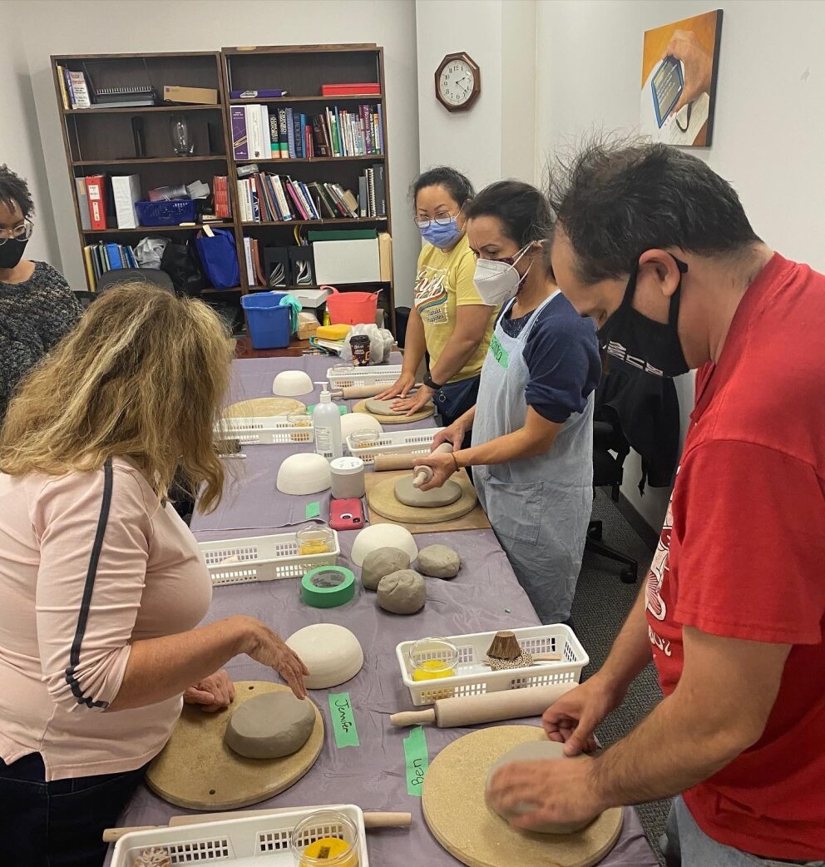
Step 1

1. Conduct a preliminary assessment to gain an understanding of BALANCE's history, purpose, programs, scope, stakeholders, and revenue sources. The planner:
Interviewed the Executive Director and reviewed relevant materials, including the 2019-21 strategic plan, progress reports, budgets, and annual reports.
Interviewed the Apprenticeship program manager, Doug Poirier.
2. Convene the Advisory Committee to conduct a focus group SWOT (Strengths, Weaknesses, Opportunities, Threats) analysis on BALANCE programs, services, and the current state, Include discussions on sector trends
Findings from the SWOT Analysis
Strengths of Current Service:
- Person-centered and customized service delivery approach catering to individual needs, including complex cases involving multiple disabilities and mental health issues.
- Quick and efficient response times compared to larger organizations. Accessibility to all clients through free services.
- Engagement of staff and service providers with lived experience, emphasizing community-focus.
- Unique programs such as adaptive daily living skills, Assistive Technology apprenticeship, and mental health supports.
Weaknesses:
- Limited capacity to reach a large number of clients due to organizational size.
- Reliance on government funding, despite efforts to diversify income sources.
- Physical location of the current office
Challenges/Threats:
- Constantly changing availability and outcomes of government funding. Competition from larger, well-known organizations for limited funding. Need to differentiate BALANCE's program offerings.
- Increasing complexity of clients' needs, influenced by multiple disabilities, mental health issues, the economy, and housing- related concerns.
Opportunities:
- Form partnerships with like-minded organizations providing complementary services in different locations. Leverage grant opportunities to fund specific programs and projects.
- Increase the utilization of volunteers for service provision, such as social groups and communication. Expand the variety of classes offered, including self-defense and yoga.

Findings from the SWOT Analysis (cont’d)
Trends in the non-profit service provision sector:
- Rise in remote (telephone/online) program and service delivery since the start of the pandemic, with considerations for accessibility to technology and Internet services.
- Growing demand for expanded access to mental health services. Financial instability and the risk of recession.
- Difficulty in recruiting qualified staff.

Incorporate the input of the SPAC members on the long-term goal and gather ideas for the external research phase of the project. Combine their input with the results from part 2.

Step 2
Idea Exploration: In-Depth Interviews
After holding individual interviews with eight of the nine SPAC members, a second meeting was held with the committee as a whole to build on the research ideas.
Based on the results of this discussion, a list of interview candidates was developed. In addition to the eight SPAC members, 12 external stakeholders were interviewed. (See appendix 2 for a list of the organizations represented by the external interviewees and/or their role and the questions asked.)
The results of both sets of interviews (SPAC members and external persons) were analyzed for common themes, including strengths of the ideas/audacious goal statement; risks and cautions; and other ideas and suggestions
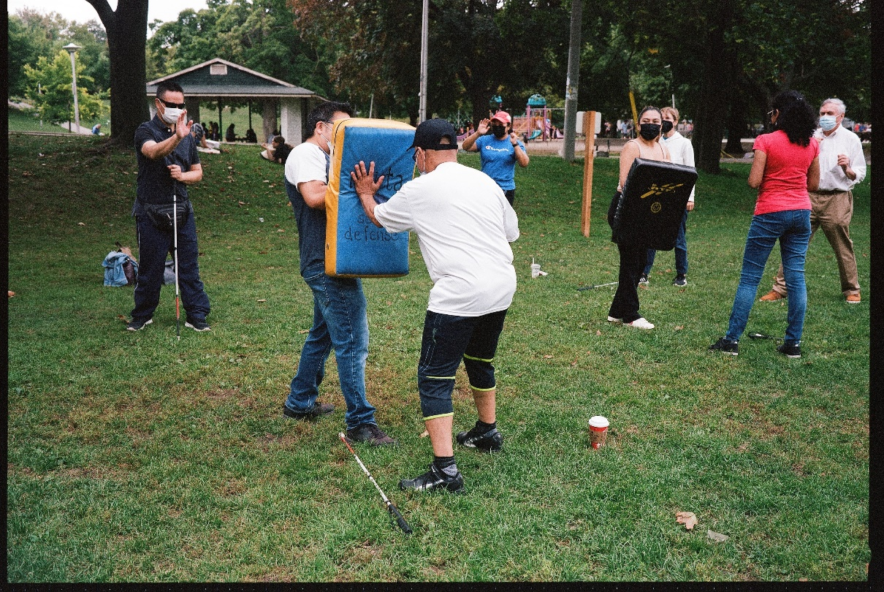

Findings
- The research covered various topics including organizational service expansion, remote service delivery, the AT Apprenticeship Program, mental health services, and partnership development.
- Feedback and suggestions were provided by interviewees on these topics.

Expansion Beyond Toronto:
- The idea of expansion received positive feedback, and a few questions were raised.
- The personalized approach of BALANCE was seen as a strength, and there were concerns about maintaining this approach during expansion.
- Expanding requires additional human and financial resources, which need to be considered.
- Balancing expansion with maintaining excellence in current service provision was suggested by some respondents.
- Planning the expansion was emphasized to ensure consistent and well-delivered services in areas with the greatest need.
- Suggestions were made regarding geographic and demographic focus areas for expansion.
Remote Service Delivery (the method for expansion):
- The pandemic highlighted the feasibility of remote service delivery, which BALANCE had considered prior to its implementation.
- Positive aspects of remote service delivery were identified, including greater acceptance, convenience, wider reach, and reduced infrastructure requirements.
- Challenges were also mentioned, such as inconsistent access to technology and connectivity, reduced socialization opportunities, and the need for in-person assistance in certain cases.

Apprenticeship Program:
- The need for assistive technology support and training was emphasized.
- The AT Apprenticeship program was praised for its "train the trainer" approach, addressing the low employment rate for visually impaired individuals, the growing need for trainers, and the value of lived experience in empowering others.
Overall, the research highlighted the potential for expansion, the benefits and challenges of remote service delivery, and the strengths of the AT Apprenticeship program.

Mental Health Supports:
All respondents strongly supported and recognized the necessity of mental health services, particularly for individuals with vision loss.
Respondents suggested that mental health support could serve as an entry point to other services and training, and highlighted the benefits of virtual delivery for individuals with sight loss.
The experience of the counsellors and the need for professional moderation in peer support groups were emphasized by the respondents.
Partnerships:
Some organizational representatives expressed interest in collaborating with BALANCE to achieve their ambitious goals. For example, the Neil Squire Society's pre-employment program in British Columbia could complement BALANCE's AT Apprenticeship Program, while the CCB's Getting Together with Technology groups could ensure ongoing discussions and shared experiences.
Other Considerations:
Respondents mentioned additional areas of importance, such as the need for more orientation and mobility training, increased awareness of issues affecting blind and low vision individuals, and accessibility training for sighted web developers.
Suggested Strategic Priorities

1. Expand mental health programs:
- Mental health services should be the focus of expansion due to their perceived effectiveness and the ability to provide them remotely.
- BALANCE should seek funding support from all levels of government to extend these services beyond Ontario.
2. Expand AT Apprenticeship Program:
- The AT Apprenticeship Program, which combines assistive technology training with paid work experience, should be expanded.
- BALANCE should conduct an environmental scan to identify areas with the greatest potential benefit and establish a business operations plan.
- Ongoing funding support should be sought to offer a consistent number of apprentice positions nationwide.
3. Provide pre-employment and job readiness training:
- In addition to the apprenticeship program, pre-employment and job readiness training should be provided to help graduates find employment.
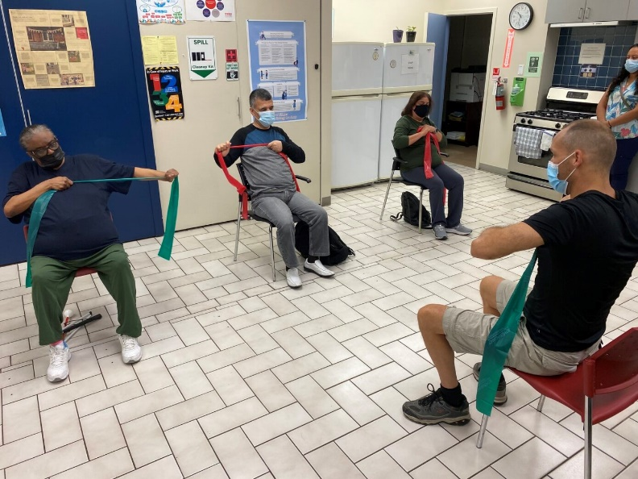
- BALANCE should monitor the existing UWGT funded BALANCE pre-employment program to assess compatibility with the Apprenticeship Program.

Operational Planning

- An operational plan with measurable goals will guide the implementation of each strategic priority.
- Research should be conducted to devise an approach for program expansion, considering factors like regional demand, resources, and delivery standards.
- Partnerships with other organizations serving people with disabilities should be explored to avoid duplication and benefit from each other's resources.

Conclusion
- There is a clear need for BALANCE's services in the blind and low vision community.
- Careful planning, in addition to further research, will result in successful achievement of plan.
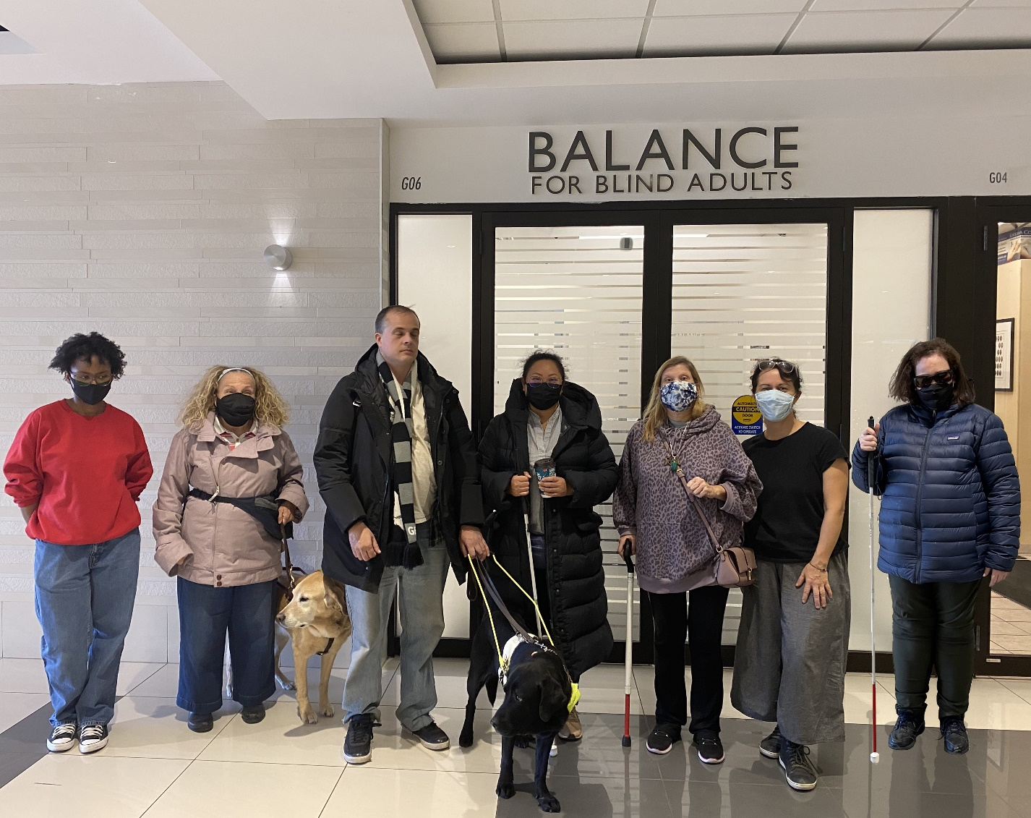
Appendix 1:

Bob Biggs, BALANCE recipient of AT Training service and group tech learning via Zoom Martin Courcelles, Board Member (professionally- CIBC Digital Accessibility Lead)

Janis Davidson-Pressick-Manager, Marketing and Communications, Accessible Media Inc. (and former Board Member, BALANCE)

Dorothy Deval-Parent of a BALANCE recipient of AT training (and other) services, BALANCE donor, and Professor of Music, York University

Windy Ho Li-former service recipient of tech training at BALANCE, first graduate of AT Apprenticeship Program, and currently employed by BALANCE as AT Trainer, part-time

Michel Pepin-Director of Sales, Humanware Canada, and Humanware sponsorship rep for AT Apprenticeship Program

Wayne Yeung-Global Health Executive, KPMG, Committee Chair, Children’s Aid Foundation Canada and Board Member, BALANCE

Also present at the 3 meetings of the committee: Deborah Gold, Executive Director, BALANCE

